CHAPTER 1: INTRODUCTION

1.1 Brief Overview of Work
In today’s digital era, online communication and remote collaboration have become essential in both professional and academic environments. With the increasing demand for virtual meetings, there is a need for efficient platforms that not only provide real-time communication but also enhance productivity and accessibility.
The proposed project, MeetRecap, is a real-time multi-user video meeting Android application developed to address these needs. The application allows users to securely log in, create or join meetings, and communicate through video and audio streams using WebRTC technology. It also integrates real-time chat functionality, screen sharing, and device controls such as microphone and camera management.
A key feature of the system is live speech-to-text captioning, which is implemented using the browser-based Web Speech API, supporting both English and Hindi languages. To ensure reliability, the system also includes Vosk as an offline fallback for speech recognition. Additionally, the application automatically generates a meeting recap in PDF format after each session and sends it to the registered email addresses of participants. This eliminates the need for manual note-taking and improves meeting efficiency.
The system uses Firebase Authentication for secure user access and Firebase Realtime Database/Firestore for storing and synchronizing real-time data. Overall, the project aims to provide a scalable, user-friendly, and feature-rich meeting platform.

1.2 Objective
The main objectives of the MeetRecap project are as follows:
- To develop a secure and user-friendly Android application for real-time video meetings.
- To enable seamless multi-user communication using video, audio, and chat features.
- To implement live speech-to-text captioning for improved accessibility.
- To support both online and offline speech recognition using Web Speech API and Vosk.
- To provide screen sharing and device control features for better interaction.
- To automatically generate meeting recap reports in PDF format.
- To send generated meeting recaps to users via email for easy access and record keeping.
- To use Firebase services for secure authentication and real-time data management.

1.3 Scope
As the demand for online communication is increasing rapidly, there is a wide scope for applications like MeetRecap. With the growth of remote work, online education, and virtual collaboration, such platforms are becoming essential in today’s digital world.
The system is useful for students, professionals, and organizations who need an efficient way to conduct meetings. It supports multiple users in a single meeting and provides real-time interaction features such as video conferencing, chat, and screen sharing. The inclusion of live captions and automatic meeting recap generation makes it more advanced than traditional meeting platforms.
In the future, the system can be enhanced by adding features such as meeting recording, AI-based summarization, multi-language support, and cloud storage integration. It can also be extended to web-based and enterprise-level applications.

1.4 Project Modules
- User Authentication: Users can register and log in securely using Firebase Authentication.

- Meeting Management: Users can create or join meetings using unique meeting IDs and manage their sessions.

- Schedule Meeting: Users can schedule meetings in advance by selecting date and time. The system stores the scheduled meeting details and allows participants to join at the specified time.

- Video & Audio Communication: Users can communicate in real time using video and audio through WebRTC technology.

- Chat System: Users can send and receive messages instantly during meetings.

- Screen Sharing: Users can share their screens with other participants during meetings.

- Device Control: Users can control microphone and camera settings such as mute/unmute and enable/disable video.

- Speech-to-Text (Captions) : The system provides live captions using the Web Speech API supporting English and Hindi.

- Offline Speech Recognition: Vosk is used as a fallback mechanism for speech recognition when internet connectivity is limited.

- Recap Generation: The system automatically generates a meeting summary in PDF format after the meeting ends.
- Email Notification: The generated PDF recap is sent to the registered email addresses of participants.

- Database Management: All user data, meeting details, and chat messages are stored and managed using Firebase Realtime Database/Firestore.

- Security & Privacy: Ensures secure data handling and controlled access using authentication and secure communication.

1.5 Project Requirements
1.5.1 Hardware
The system requires the following hardware:
- Android Smartphone (Android version 7.0 or above recommended)
- RAM: Minimum 2 GB (4 GB or higher recommended)
- Storage: Minimum 64 GB (as per user requirement)
- Camera: Required for video communication
- Microphone: Required for audio communication
- Internet Connection: Stable 4G/5G or Wi-Fi for real-time communication

1.5.2 Software
- Platform: Android Operating System
- Programming Language: Kotlin / Java
- Development Tool: Android Studio
- Backend Services: Firebase (Authentication, Firestore/Realtime Database)
- Communication Technology: WebRTC
- Speech Recognition: Web Speech API (online), Vosk (offline fallback)
- PDF Generation Library: Android-compatible PDF libraries
- Email Service Integration: SMTP / Firebase / Third-party APIs

Chapter 2: System Analysis
2.1 Literature Review
Online communication systems have evolved significantly over the years. Earlier, communication and meetings were mostly conducted physically or through basic telecommunication methods such as phone calls and emails. These traditional methods were time-consuming, lacked real-time collaboration, and were not suitable for remote environments.
With the advancement of the Internet, video conferencing platforms emerged, enabling users to communicate remotely. Popular platforms introduced features like video calls, messaging, and screen sharing. However, many existing systems still lack advanced features such as real-time transcription, multilingual captioning, and automatic meeting documentation.
Modern systems are now focusing on improving accessibility and productivity. Features like live speech-to-text, real-time chat, and cloud-based data storage have become essential. Despite these advancements, there is still a need for systems that integrate all these functionalities into a single, user-friendly platform.
The proposed system MeetRecap addresses these limitations by providing a complete solution that includes real-time video meetings, live captions (English and Hindi), offline speech recognition support, and automatic meeting recap generation with email delivery. This makes the system more efficient compared to traditional and existing platforms.

2.2 Project Feasibility Study
2.2.1 Technical Feasibility
Technical feasibility focuses on evaluating whether the proposed system can be developed using available technologies and resources. The MeetRecap project is technically feasible as it uses modern and widely adopted technologies such as Android (Kotlin/Java), Firebase services, and WebRTC for real-time communication.
Firebase Authentication ensures secure user login, while Firebase Realtime Database/Firestore enables real-time data synchronization. WebRTC technology is used for implementing video and audio communication efficiently. Additionally, the Web Speech API is used for live captions, with Vosk integrated as an offline fallback for speech recognition.
All these technologies are well-supported, scalable, and suitable for building a high-performance mobile application.

2.2.2 Economical Feasibility
Economical feasibility evaluates whether a project can be successfully developed, deployed, and sustained within a reasonable budget, weighing the anticipated costs against the project's practical value. For the MeetRecap system, the economic analysis heavily favors development, as the platform is strategically designed to minimize both initial capital expenditure (CapEx) and ongoing operational costs (OpEx).
The system is highly cost-effective and financially viable due to the following key factors:
- Utilization of Open-Source Technologies: By building the core architecture on open-source frameworks, the project completely eliminates the need for expensive commercial software licenses or proprietary tools. This ensures that the foundational development of core features—such as instant room link sharing, meeting ID generation, and the session management interface—remains entirely budget-friendly.
- Strategic Use of Cloud Computing (Firebase): MeetRecap leverages modern cloud-based services, specifically utilizing the free tiers of platforms like Google Firebase. This approach provides enterprise-grade database management, secure user authentication, and reliable hosting without the prohibitive upfront costs of purchasing, configuring, and maintaining physical in-house servers.
- Optimized for Team Syncs and Scheduling: As the system manages live team syncs and pre-scheduled sessions, cloud hosting ensures reliable uptime and seamless data synchronization without localized infrastructure expenses. The cloud provider absorbs the overhead of server maintenance and security patching.
- Minimal Hardware Requirements: The development, testing, and deployment of the application do not require high-end or specialized hardware. Standard computer systems are fully sufficient for the development lifecycle. Furthermore, end-users can access the platform via standard devices, removing financial barriers for the target audience.
- Scalable "Pay-as-You-Grow" Model: While the initial development and testing phases operate comfortably within free-tier cloud limits, the architecture is inherently scalable. If MeetRecap transitions to a larger real-world application with high traffic, the infrastructure costs will only increase proportionally with active user growth. This prevents the financial risk of paying for server capacity before it is actually needed.

2.2.3 Operational Feasibility
Operational feasibility evaluates how effectively a proposed system will solve the targeted problems, how well it integrates into the daily workflows of its intended users, and the overall likelihood of user adoption. For the MeetRecap system, operational feasibility is exceptionally high, as the platform is specifically engineered to eliminate friction in communication and enhance productivity without requiring extensive user training.
The system's real-world practicality is driven by the following operational strengths:
- User-Centric Design and Low Learning Curve: The application is designed to be highly intuitive, catering to users with varying levels of technical expertise. By utilizing modern, responsive UI design principles—such as smooth navigation and clearly defined call-to-action buttons for joining or creating rooms—the system ensures that users can onboard instantly. This seamless experience minimizes resistance to adoption in both corporate and educational environments.
- Frictionless Session Management: MeetRecap simplifies the logistical challenges of digital communication. The ability to start a room and share a link instantly, combined with the capability to efficiently pre-schedule sessions for team syncs, ensures that the platform adapts to both spontaneous collaborations and structured, long-term project planning.
- Comprehensive and Accessible Control Suite: Once inside a meeting, the operational flow remains uninterrupted. The system provides easily accessible, intuitive controls for core functions including video toggling, audio muting, integrated text chat, and dynamic screen sharing. These tools are placed strategically within the interface to allow presenters and participants to interact without disrupting the flow of the meeting.
- Automated Productivity and Accessibility Tools: What elevates MeetRecap beyond a standard communication tool is its operational focus on post-meeting productivity. Features like live captions make the platform highly inclusive and accessible in noisy environments or for users with hearing impairments. Furthermore, the automatic recap generation dramatically reduces the administrative burden of manual note-taking, ensuring that action items and key takeaways are instantly available for distribution.
- Platform Independence and Adaptability: Because the system operates efficiently within standard web environments, it does not require users to install heavy, localized software or undergo complex configuration processes. This high degree of adaptability means it can be deployed seamlessly across different devices and operating systems.

2.3 Project Timeline Chart
The development of the MeetRecap project is carried out in multiple phases, including planning, design, development, testing, and deployment.

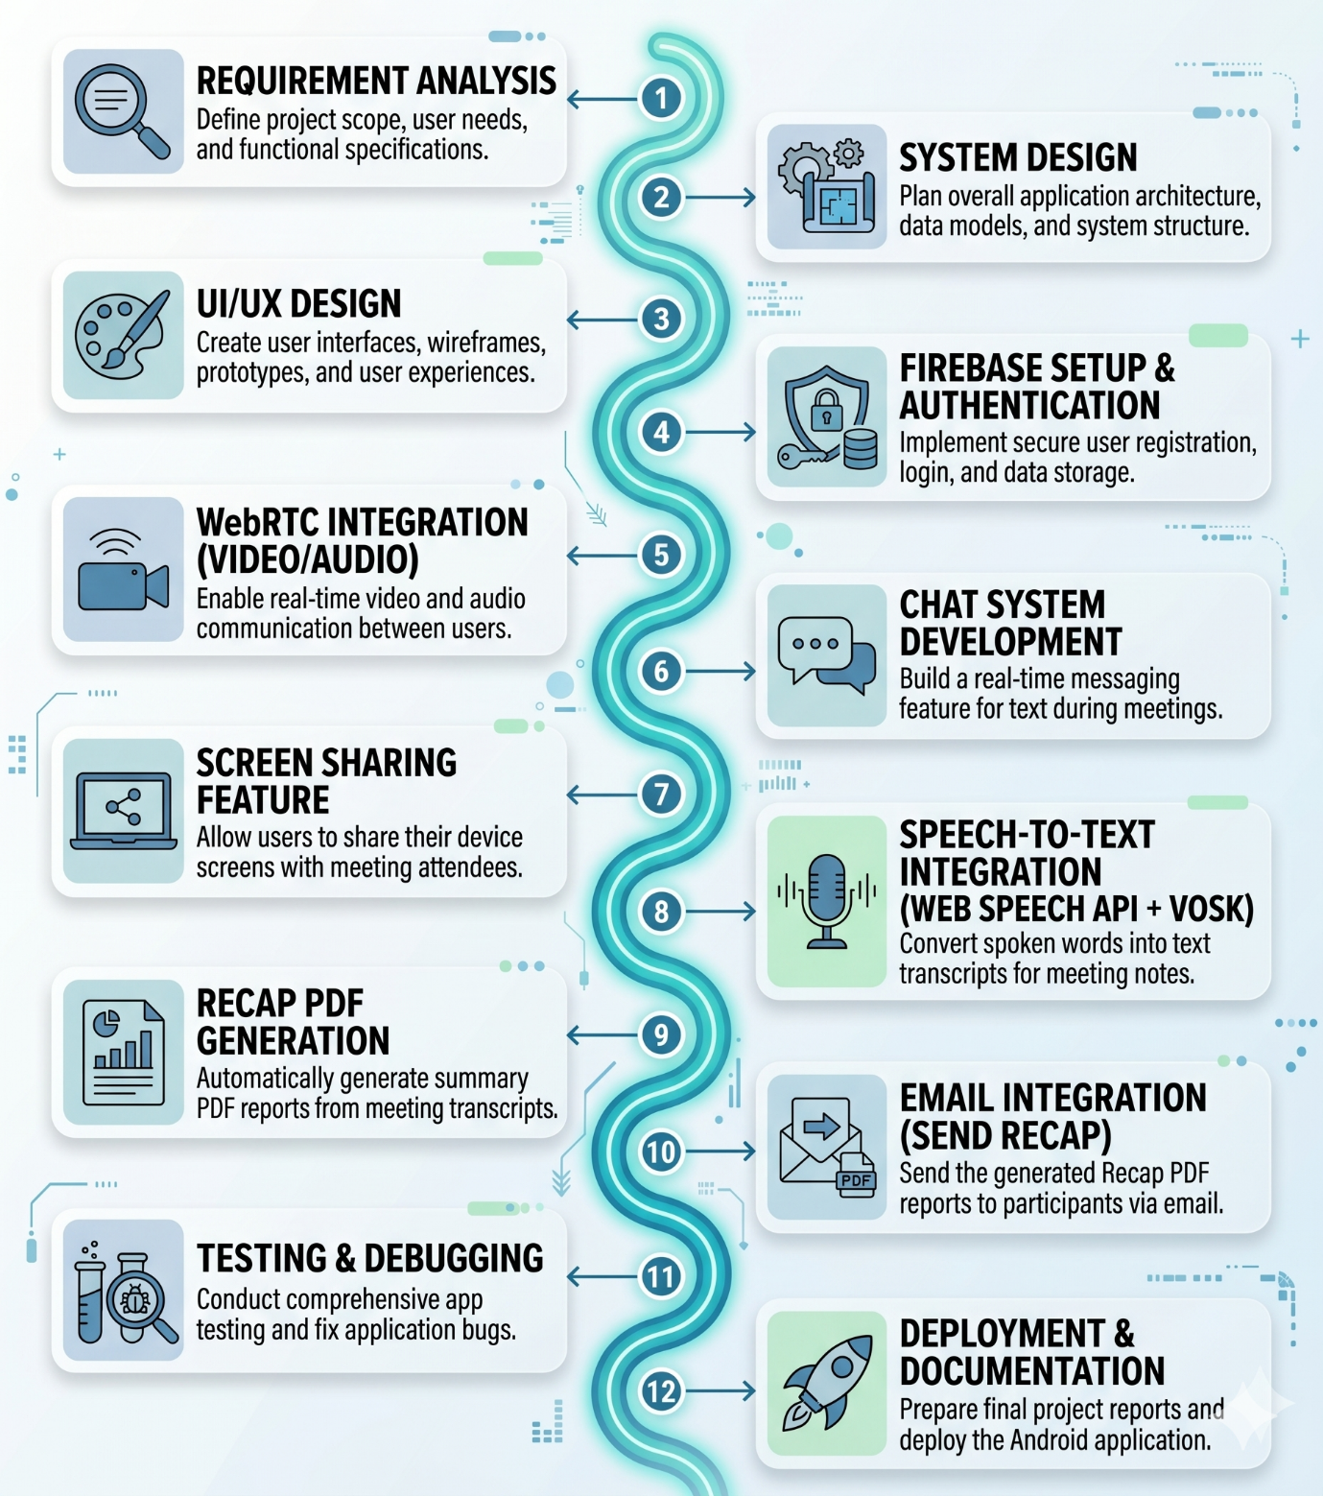
Figure 2.1 – Timeline Chart

2.4 Detailed Module Description with all Functionalities
This section provides an in-depth breakdown of the functional modules that constitute the MeetRecap ecosystem. Each module is engineered to handle specific tasks, ensuring a modular, maintainable, and high-performance application.

2.4.1 User Authentication
This module serves as the primary security gatekeeper. Powered by Firebase Authentication, it manages the entire user lifecycle from onboarding to secure logout.
- Secure Onboarding: Supports email/password registration with built-in validation for password strength and email formatting.
- Session Management: Maintains persistent login states using secure tokens, ensuring users don't have to log in every time they open the app.
- Identity Protection: Implements industry-standard encryption for sensitive credentials, protecting the user's digital identity from unauthorized access.
2.4.2 Meeting Management
The core orchestration unit that handles the lifecycle of a live session.
- Instant Room Creation: Generates unique, non-repeating Meeting IDs for immediate collaboration.
- Dynamic Joining: Validates Meeting IDs in real-time, allowing participants to enter rooms with a single tap.
- Participant Tracking: Manages a live list of active users, identifying the host and handling "user joined" or "user left" events gracefully.
2.4.3 Schedule Meeting
Designed for structured collaboration, this module allows users to plan ahead.
- Temporal Planning: Users can select specific dates and times using an intuitive calendar and clock interface.
- Pre-Allocation: Reserves a specific meeting environment in advance, ensuring the host has a ready-to-use link for their team sync.
- Invitee Management: Allows hosts to pre-set a list of expected participants, streamlining the eventual distribution of the meeting recap.
2.4.4 Video & Audio Communication
The engine for real-time interaction, utilizing WebRTC for high-fidelity media transmission.
- Low-Latency Streaming: Establishes peer-to-peer (P2P) tunnels to ensure voice and video are synchronized with minimal lag.
- Adaptive Quality: Automatically adjusts video resolution based on the user's current bandwidth to prevent call drops.
- Multi-User Sync: Manages complex signaling to allow multiple participants to interact simultaneously in a single virtual space.
2.4.5 Chat System
A real-time text-based collaboration tool that operates alongside the video feed.
- Instant Messaging: Uses the Firebase Realtime Database to deliver messages with millisecond latency.
- Collaborative Threading: Enables users to share links, snippets, and quick questions without interrupting the speaker.
- Data Capture: The chat history is monitored by the system to ensure important text-based insights are preserved for the final recap.
2.4.6 Screen Sharing
A professional-grade tool for presentations and technical demonstrations.
- Live Casting: Allows any participant (with host permission) to broadcast their screen to the entire room in high definition.
- Resource Efficiency: Optimized to balance screen clarity with frame rate, ensuring that slides or code remain legible for all viewers.
2.4.7 Device Control
Provides users with granular control over their hardware for privacy and professional conduct.
- Toggle Interface: Simple, responsive buttons to mute/unmute microphones and enable/disable camera feeds.
- Status Indicators: Real-time visual cues (icons) that show other participants who is speaking or who has their video turned off.
2.4.8 Speech-to-Text (Live Captions)
Enhances accessibility and understanding through real-time transcription.
- Bilingual Support: Utilizes the Web Speech API to process and display captions in both English and Hindi, catering to a diverse user base.
- Visual Overlay: Displays text at the bottom of the screen in a readable, high-contrast format, ensuring no dialogue is missed in noisy environments.
2.4.9 Offline Speech Recognition
The "fail-safe" module for unreliable network conditions.
- Vosk Integration: Implements a localized Machine Learning model that processes speech directly on the device.
- Seamless Fallback: If the internet connection fluctuates, the system switches to Vosk to ensure captions and data for the recap continue to be captured without interruption.
2.4.10 Recap Generation
The standout feature of MeetRecap that automates the documentation process.
- Data Synthesis: Once the meeting ends, this module compiles the transcript, chat logs, and meeting metadata.
- Professional PDF Formatting: Converts the raw data into a clean, structured PDF report featuring the meeting title, host name, duration, and key discussion points.
2.4.11 Email Notification
The distribution arm that ensures the meeting's value lasts beyond the call.
- Automated Dispatch: Immediately follows the PDF generation by triggering an email service (SMTP).
- Verified Delivery: Sends the recap directly to the registered email addresses of all participants, eliminating the need for manual follow-ups.
2.4.12 Database Management
The central nervous system for data persistence and synchronization.
- Hybrid Storage: Utilizes Firebase Realtime Database for live interactions (chat/status) and Firestore for persistent records (user profiles/history).
- Cloud Synchronization: Ensures that data is updated across all participant devices instantly, maintaining a "single source of truth" for the meeting state.
2.4.13 Security & Privacy
The foundational layer that protects the entire application.
- Encrypted Transmission: All data sent between the client and the backend is protected via SSL/TLS encryption.
- Privacy-First Purging: Implements a strict policy where temporary session data (like raw audio/video and chat logs) is wiped from the database after the meeting ends and the recap is sent, ensuring user confidentiality.

Chapter 3: System Design
3.1 Introduction
System design serves as the foundational blueprint for the MeetRecap application, detailing the technical framework required to transform conceptual requirements into a functional, high-performance reality. It goes beyond simple aesthetics to define the overall structure, architecture, and modular components that allow the platform to facilitate seamless collaboration. By establishing a robust architectural plan, the system design ensures that MeetRecap remains reliable under varying loads while maintaining the integrity of user data.
The system design for MeetRecap is structured around several critical pillars:
- Modular Architecture and Component Interaction: The application is designed as a collection of interconnected modules—such as the User Authentication Module, Real-Time Communication (RTC) Engine, and the Data Processing Layer. The design specifically illustrates how these modules communicate; for instance, how the RTC engine triggers the Recap Generation functionality once a session concludes. This modularity allows for easier maintenance and independent updates to specific features without disrupting the entire ecosystem.

- Real-Time Communication (RTC) Framework: At the heart of the system is the architecture for low-latency audio and video transmission. The design specifies the protocols used for instant room creation and link sharing, ensuring that the transition from clicking a "Join" button to active participation is near-instantaneous. It outlines the data flow between peers and servers to minimize lag and maximize clarity.

- Scalability and Performance Optimization: A core focus of the system design is ensuring that MeetRecap can grow alongside its user base. By utilizing a cloud-native architecture, the system can handle an increasing number of concurrent sessions and users without a degradation in performance. The design incorporates efficient resource management strategies, such as load balancing and optimized database queries within the Firebase environment, to maintain high-speed responses.

- Security and Data Integrity: The system design integrates security at every layer. This includes defining the encryption protocols for data in transit during live sessions and the secure storage of meeting metadata and generated recaps. It outlines the permission-based access control system, ensuring that only authorized team members can join specific meeting IDs or access archived session summaries.

- Automated Workflow Integration: The design explicitly maps the logic for the Automatic Recap Generation. It defines how the system captures meeting data, processes it through the recap engine, and stores the final output for team review. This automation is a key differentiator, and its design ensures that the transition from a live discussion to a documented summary is both accurate and efficient.
3.2 System Architecture
The MeetRecap system is built upon a robust, distributed Client-Server Architecture optimized for low-latency communication and high-speed data processing. By leveraging a combination of peer-to-peer protocols and cloud-based backend services, the architecture ensures that the application remains responsive, secure, and capable of handling complex tasks like real-time transcription and automated reporting.

3.2.1 Architectural Components
- Android Application (Client Layer): The client-side serves as the primary interface for the user, developed with a focus on responsiveness and performance. It manages the Application Logic, rendering the UI, and handling sophisticated meeting controls. It acts as the orchestration layer that coordinates between the user's hardware (camera/microphone) and the external cloud services.
- Firebase Cloud Ecosystem (Backend-as-a-Service): Firebase serves as the backbone of the application’s non-media data.
  - Firebase Authentication: Provides a secure, encrypted gateway for user entry.
  - Real-time Database/Firestore: Manages the live state of meeting rooms, participant lists, and synchronization of chat messages with millisecond latency.
  - Cloud Storage: Safely stores generated recap documents and user profile assets.
- WebRTC (Real-Time Communication Layer): To facilitate high-quality video and audio, MeetRecap utilizes WebRTC (Web Real-Time Communication). This protocol allows for direct peer-to-peer (P2P) streaming, which significantly reduces server load and latency. It handles the complexities of NAT traversal, STUN/TURN servers, and adaptive bitrate streaming to ensure a stable connection even on fluctuating networks.
- Hybrid Speech Recognition Engine: To provide high-accuracy live captions, the system employs a dual-layered approach:
  - Web Speech API: Utilized for high-speed, cloud-based transcription when internet connectivity is optimal.
  - Vosk (Offline-Capable ML): Integrated as a fail-safe or supplementary engine to ensure that speech-to-text processing remains consistent and privacy-focused, handling the heavy lifting of audio-to-data conversion.
- Recap Generation & Dispatch Services: This specialized module intercepts the transcribed text data and meeting metadata at the conclusion of a session. It utilizes PDF Generation libraries to format the discussion into a professional summary and integrates with SMTP/Email APIs (such as Nodemailer or SendGrid) to automate the delivery of these reports to all registered participants.

3.2.2 Comprehensive Working Flow
The operational lifecycle of a MeetRecap session follows a structured, sequential pipeline to ensure data integrity and a smooth user experience:
- Secure Access: The process begins with Firebase Authentication, where users are verified via email or OAuth, granting them a unique session token for secure communication.
- Room Orchestration: A user either initializes a new session (generating a unique Meeting ID) or enters an existing one. The system queries the Firebase Real-time Database to sync the current room state and participant permissions.
- P2P Handshaking: The WebRTC signaling process commences, exchanging "offers" and "answers" to establish a direct, encrypted media tunnel between participant devices for audio and video transmission.
- Concurrent Data Streams: While the media flows via WebRTC, the application simultaneously streams audio fragments to the Speech Recognition Engine. In parallel, text-based chat and system events (like "user joined") are logged in the real-time database.
- Live Captioning: The speech engine converts audio into text in real-time, which the UI overlays as captions, enhancing accessibility for all users.
- Post-Session Processing: Upon the termination of the meeting, the system triggers the Recap Logic. It compiles the accumulated transcriptions and chat logs into a structured PDF document.
- Automated Distribution: Finally, the system identifies the participant list from the session metadata and dispatches the PDF recap via the Email Service, ensuring that the "Meet-to-Recap" cycle is completed without manual intervention.

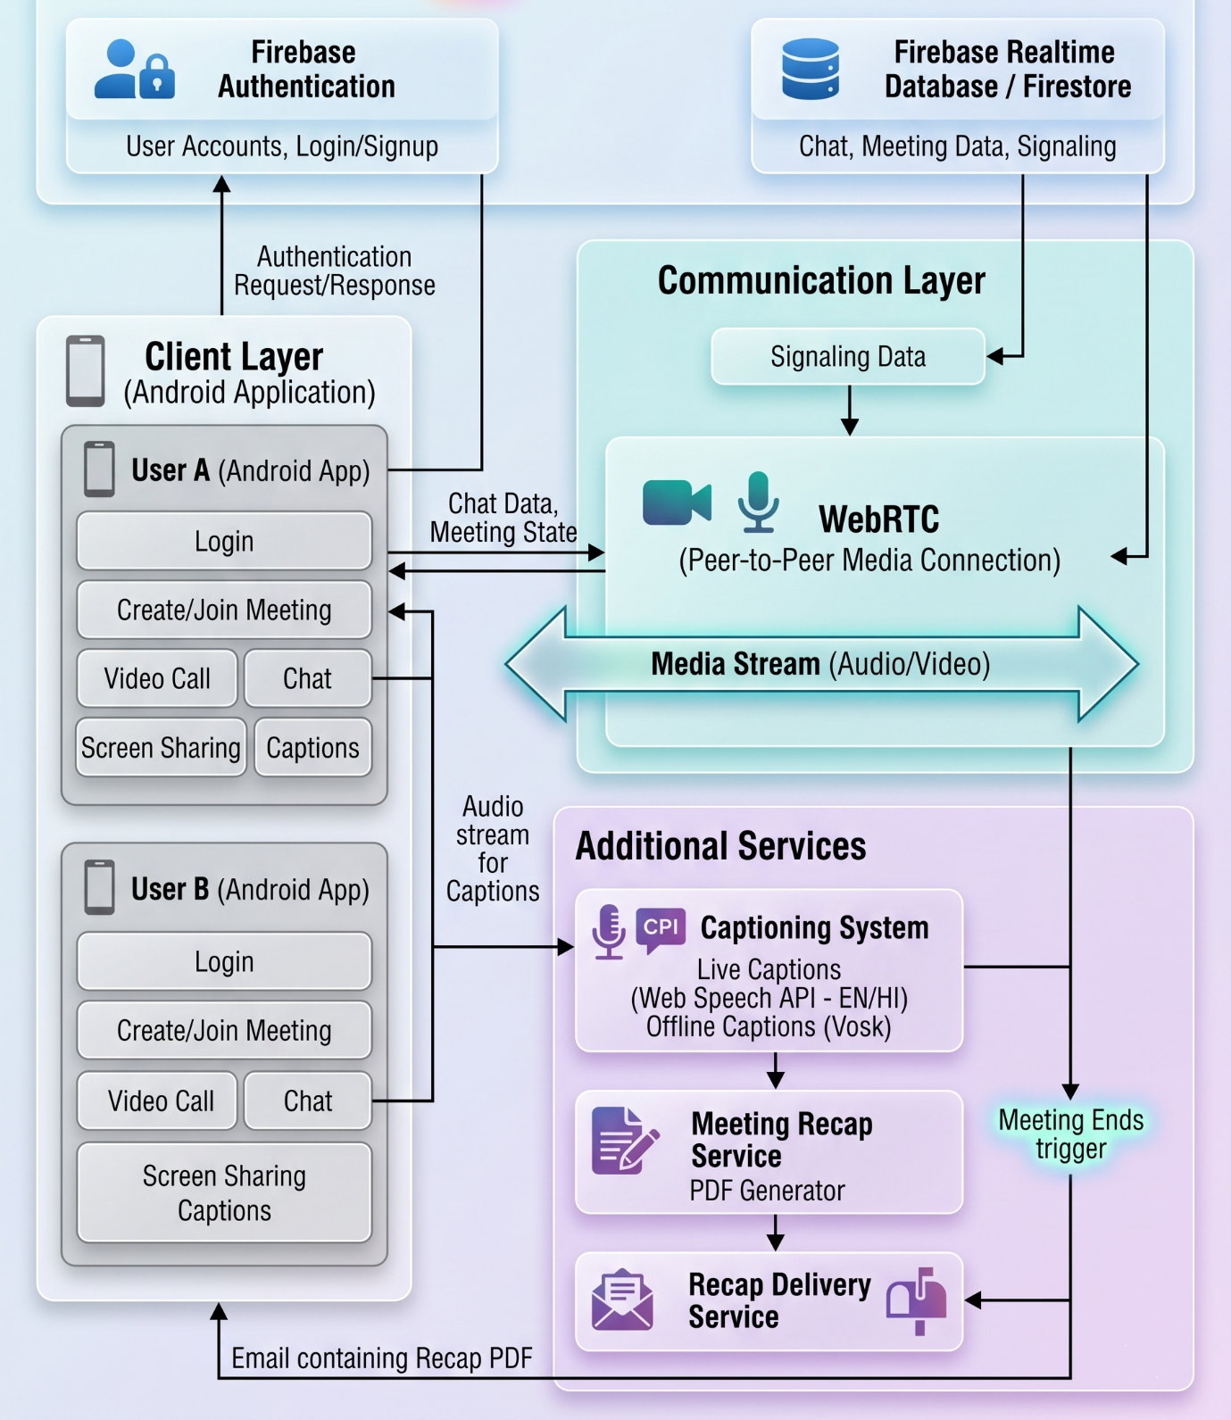
Figure 3.1 – Architecture Diagram

3.3 Use Case Diagram
The Use Case Diagram represents interactions between the User and the system.
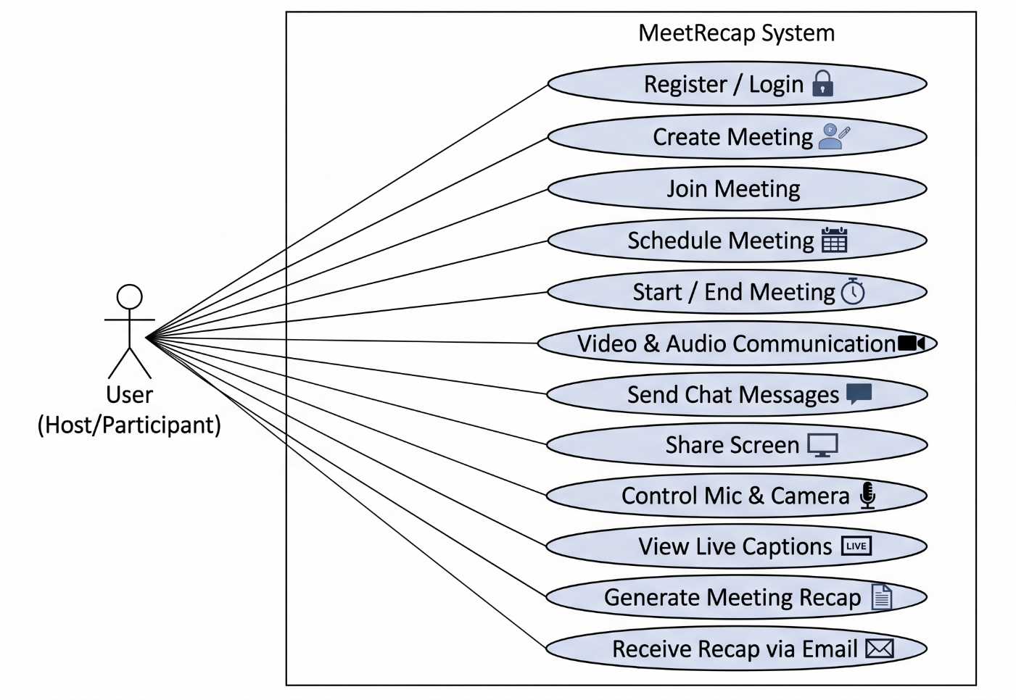
Figure 3.2 – Use Case Diagram

3.4 Data Flow Diagram (DFD)
The Data Flow Diagram shows how data moves within the system.
Level 0 (Context Diagram):
- User interacts with MeetRecap System
- System communicates with Firebase and WebRTC
Level 1:
- Authentication Process
- Meeting Management
- Communication Flow
- Recap Generation & Email System

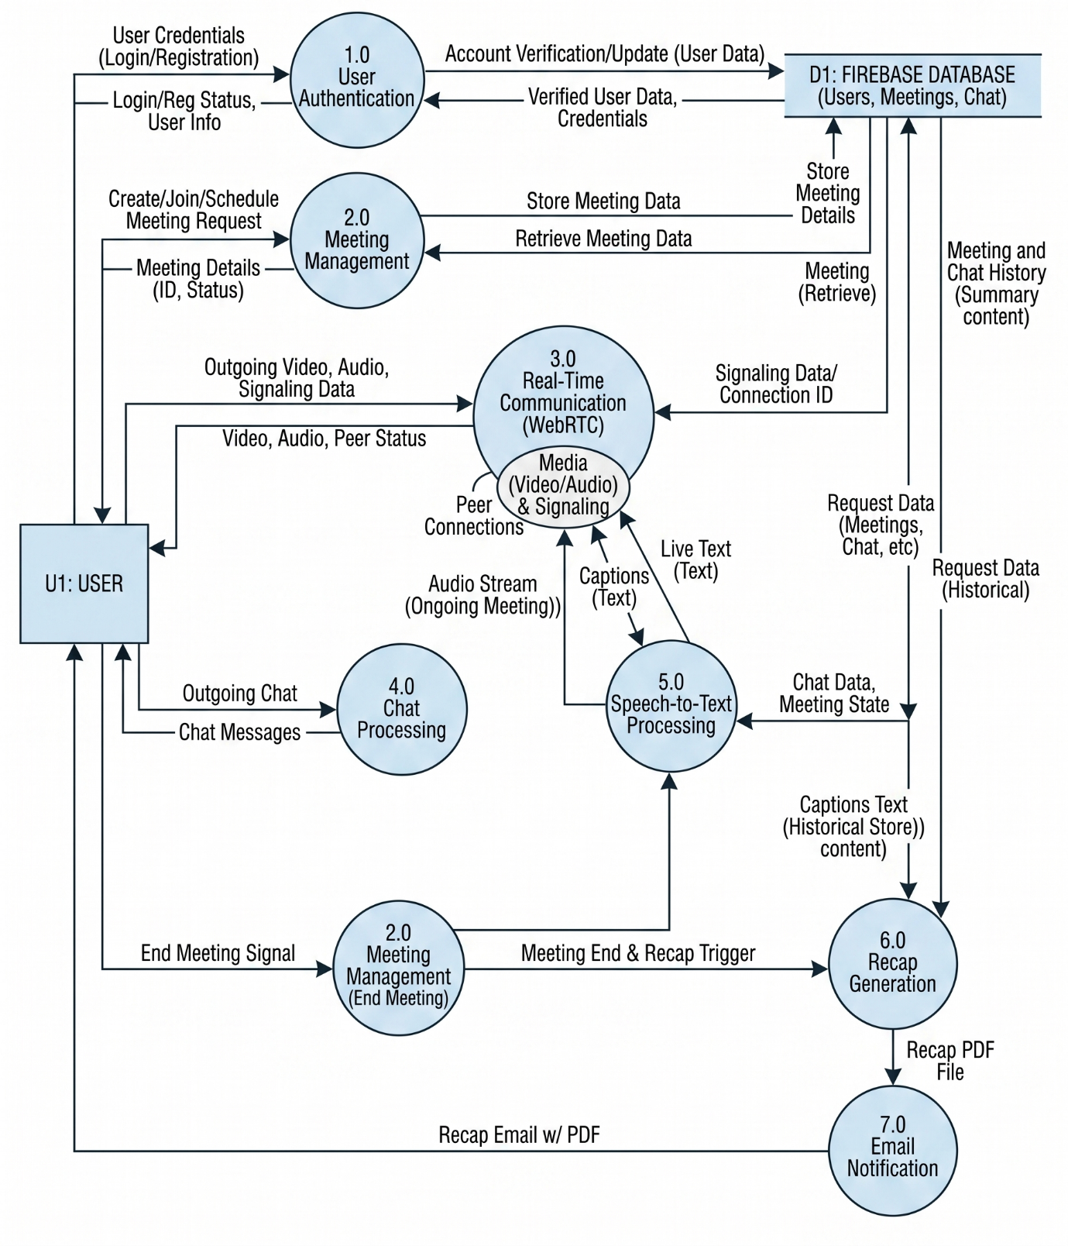
Figure 3.3 – Data Flow Diagram

3.5 Flowchart
The flowchart represents the step-by-step working of the system.
Flow:
Start → Login/Register → Dashboard →
Create/Join Meeting →
Meeting Active (Video + Chat + Captions) →
End Meeting → Generate PDF → Send Email → End

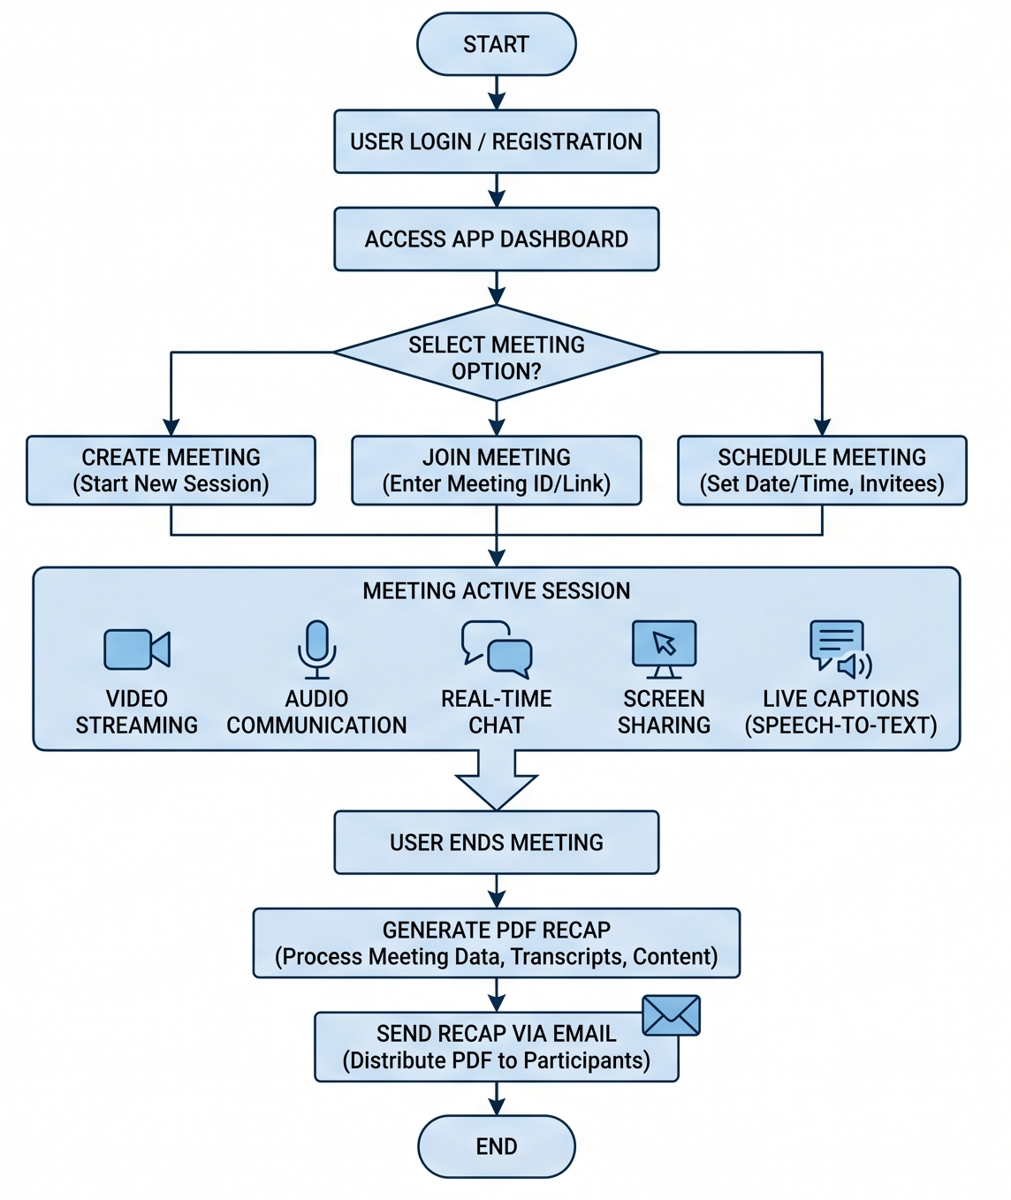
Figure 3.4 – Flowchart
3.6 Entity Relationship Diagram (ERD)
The Entity Relationship Diagram (ERD) serves as the logical blueprint for the MeetRecap database. It illustrates how various data objects—referred to as entities—interact within the ecosystem to support real-time communication and automated reporting. By defining these relationships, the ERD ensures data integrity, prevents redundancy, and facilitates efficient querying within the Firebase environment.
Below is a detailed breakdown of the entities, their specific attributes, and the relational logic that governs the system.

3.6.1 Entities and Attribute Descriptions
Each entity represents a core data object required to manage the lifecycle of a meeting.
- User Entity: This represents every registered individual on the platform.
  - user_id (Primary Key): A unique identifier (UID) generated by Firebase Authentication.
  - name: The display name of the user.
  - email: The verified email address used for login and for receiving meeting recaps.
- Meeting Entity: This entity tracks the creation and scheduling of virtual rooms.
  - meeting_id (Primary Key): A unique code (e.g., abc-uuid-xyz) generated for every session.
  - host_id (Foreign Key): References the user_id of the person who initiated the room.
  - time: A timestamp indicating when the meeting was created or scheduled to start.
- Participant Entity: This is a associative entity (or junction table) that manages the many-to-many relationship between users and meetings.
  - user_id (Foreign Key): Links back to the User.
  - meeting_id (Foreign Key): Links to the specific Meeting they joined.
- Chat Entity: This logs the real-time communication history of a session.
  - message_id (Primary Key): A unique ID for every individual chat bubble.
  - sender_id (Foreign Key): References the user_id of the participant who sent the message.
  - message: The actual text content of the message.
  - timestamp: (Optional but critical) Tracks exactly when the message was sent for chronological ordering.
- Recap Entity: This represents the final output of the MeetRecap system.
  - recap_id (Primary Key): A unique ID for the generated document.
  - meeting_id (Foreign Key): A 1:1 link to the meeting that provided the source transcript.
  - pdf_link: The URL pointing to the file stored in Firebase Cloud Storage.

3.6.2 Relational Logic & Cardinality
The ERD defines the "rules" of how these entities talk to one another:
- User ➔ creates ➔ Meeting (1:N): A single User can host multiple Meetings over time, but each specific meeting instance is initially created by one unique Host. This establishes a one-to-many relationship.
- Meeting ➔ has ➔ Participants (1:N): Each Meeting serves as a container for multiple Participants. While a user can participate in many meetings, for a specific meeting_id, there is a list of distinct users associated with that session.
- Participants ➔ send ➔ Messages (1:N): A Participant within a specific meeting can send any number of Messages. Each message is uniquely tied back to its sender to ensure that the chat log and eventual recap accurately attribute statements to the correct person.
- Meeting ➔ generates ➔ Recap (1:1): To maintain clarity, each Meeting produces exactly one official Recap document. This one-to-one relationship ensures that users receive a consolidated summary of the entire session rather than fragmented reports.

3.6.3 Operational Importance of the ERD
This structure allows the MeetRecap system to perform complex tasks instantly. For example, when the meeting ends, the system uses the meeting_id to pull all related Messages and Participant names, processes them through the Speech Recognition API logic, and finally creates the Recap entry with a pdf_link that is emailed to all emails associated with that specific meeting_id.

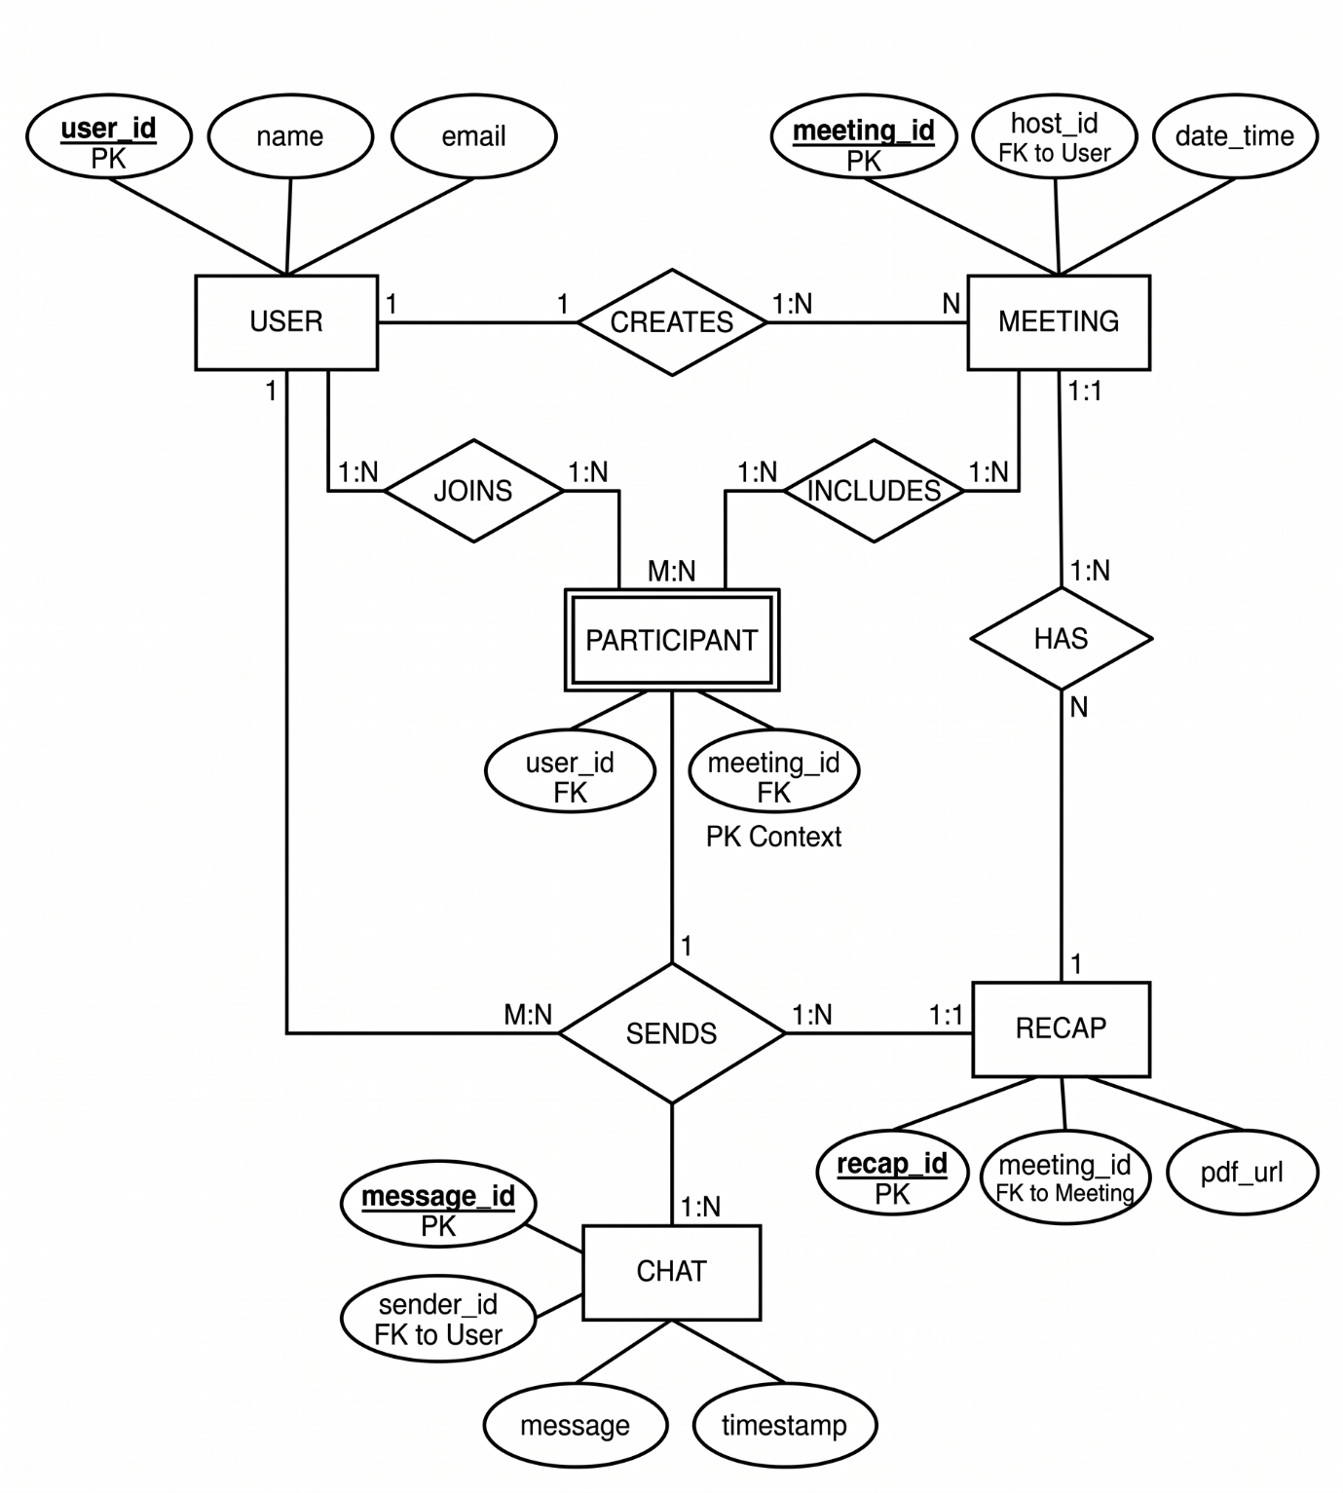

Figure 3.5 – ER Diagram

3.7 Activity Diagram
The Activity Diagram shows workflow of user actions.

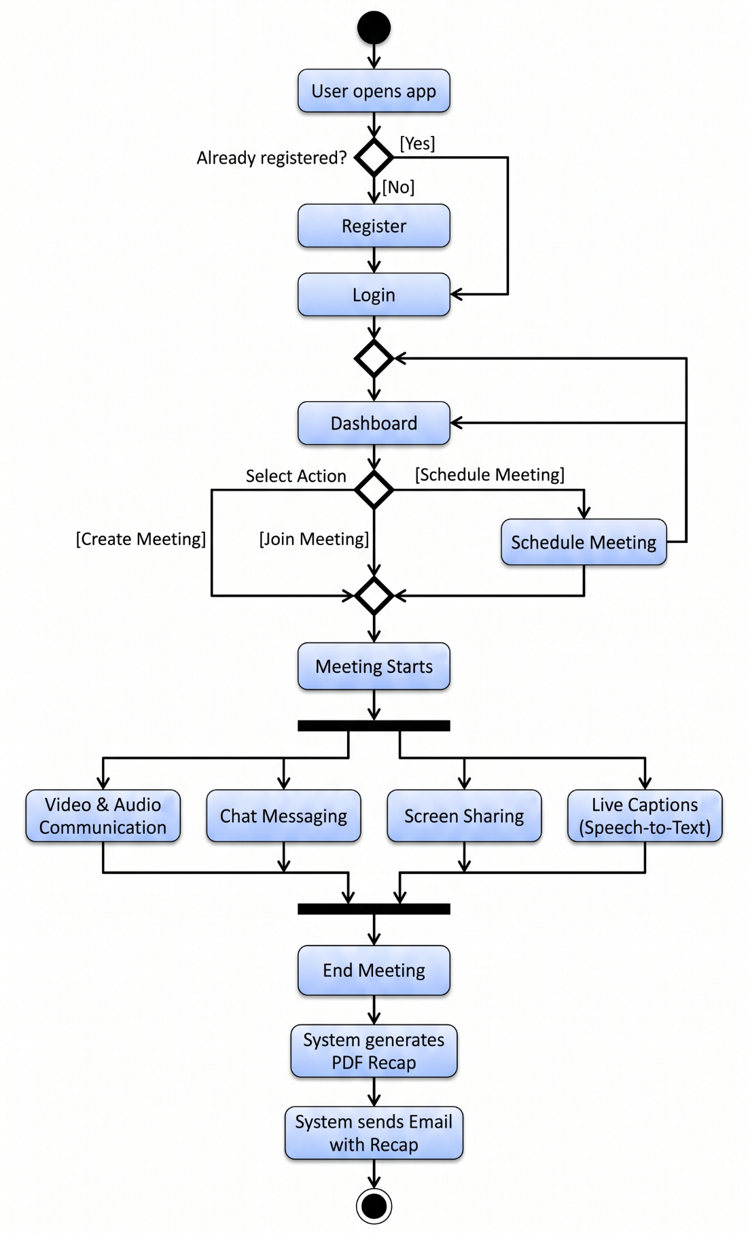
Figure 3.6 – Activity Diagram

3.8 Data Dictionary (Database)
The data dictionary provides a detailed breakdown of the information architecture within the MeetRecap ecosystem. It defines the metadata, data types, and storage constraints for every attribute utilized by the system. To ensure optimal performance and user privacy, the database is partitioned into Persistent Storage (long-term records) and Volatile/Temporary Data (session-only information).
By strictly managing what is stored permanently versus what is purged, the system remains compliant with modern data protection standards while minimizing infrastructure overhead.

3.8.1 User Table
This table acts as the primary identity registry. It is utilized by Firebase Authentication to manage access control and by the reporting module to identify recap recipients.

Attribute | Data Type | Description
user_id | String | A unique, non-null UUID generated by Firebase for each registered account.
name | String | The full name provided by the user; used for display in meetings and PDF headers.
email | String | The primary contact address; used as the unique login credential and for PDF delivery.
password | String | An encrypted, salted hash of the user's password. The raw password is never stored.
account_created | DateTime | (Optional) Tracks when the user first registered for audit and loyalty purposes.
Table 3.1: User Table
3.8.2 Meeting History Table
This persistent table serves as a log for all concluded sessions. It allows users to track their past activities without storing the heavy media files associated with those sessions.

Attribute | Data Type | Description
meeting_id | String | The unique alphanumeric room code assigned to the session.
host_id | String | A foreign key linking to the user_id of the individual who organized the meeting.
timestamp | DateTime | The exact date and time the session was initialized.
duration | Integer | (Added) The total length of the meeting in minutes for analytical reporting.
Table 3.2: Meeting History Table

3.8.3 Scheduled Meeting Table
This table facilitates the "Pre-schedule" feature, allowing the system to send reminders and reserve room IDs for future team syncs.

Attribute | Data Type | Description
meeting_id | String | A pre-allocated identifier reserved for the upcoming session.
host_id | String | The user ID of the organizer responsible for the invitation.
scheduled_time | DateTime | The future date and time when the meeting is set to commence.
participants | Array/List | A collection of user IDs or email addresses invited to the session.
meeting_topic | String | (Added) A brief title or agenda to provide context in the invitation email.
Table 3.3: Scheduled Meeting Table
3.8.4 Chat Data (Temporary / Volatile)
To maintain a "lean" database and protect user privacy, chat logs are treated as transient objects.
- Runtime Presence: Messages are stored in a temporary Firebase node only during the "Active" state of a meeting.
- Purge Logic: Once the host terminates the session or all participants leave, the chat node for that meeting_id is programmatically deleted.
- Persistence via Recap: Critical dialogue and shared text are extracted by the Recap Engine just before the purge to be included in the permanent PDF summary.

3.8.5 Session Data (Temporary)
This encompasses the high-bandwidth media streams that facilitate the meeting experience.
- WebRTC Handling: Video and audio streams are transmitted P2P (Peer-to-Peer). MeetRecap acts as a conduit for these streams but does not record or "write" this media to a server.
- Privacy & Performance: By not storing raw video/audio files, the system avoids massive storage costs and ensures that sensitive conversations are never at risk of being leaked from a static server.
- Zero-Footprint Policy: All temporary signaling data used to establish the WebRTC connection is destroyed immediately after the "handshake" is complete.

3.8.6 Email & Recap Data
The Recap Data represents the bridge between temporary session activity and permanent documentation.
- PDF Generation: The system aggregates transcripts, chat highlights, and participant lists into a structured PDF document.
- The "Recap Record" Strategy: Instead of maintaining a database of raw text, the PDF serves as the immutable record. Once the PDF is generated and successfully dispatched via the Email Service, the source transcript data is wiped from the application's memory.
- Delivery Confirmation: The system logs a "Success" status in the Meeting History once the email is sent, providing a verifiable audit trail for professional and academic users.

Chapter 4: Software Tools
4.1 Introduction
The development of the MeetRecap application involves the use of various modern software tools and technologies that enable real-time communication, data management, and intelligent features such as speech recognition and automated recap generation. These tools are selected based on their performance, scalability, ease of integration, and industry relevance. This chapter provides a detailed overview of the software tools and technologies used in the development of the system.

4.2 Frontend (Client-Side)
Android (Kotlin)
The frontend of the MeetRecap application is developed using the Android platform, primarily utilizing Kotlin along with Java. Android provides a robust environment for building mobile applications with rich user interfaces and smooth performance. Kotlin is preferred due to its modern syntax, null safety, and improved readability, which helps in reducing code complexity and development time.
The Android application handles all user interactions, including login, meeting creation, joining sessions, chat functionality, and device controls such as microphone and camera management. It also manages UI components like buttons, layouts, and activity transitions, ensuring a seamless and user-friendly experience. Android Studio is used as the primary development environment for building, testing, and debugging the application.
Kotlin is a modern programming language developed by JetBrains, the company known for tools like IntelliJ IDEA. It was first introduced in 2011 and officially released in 2016. Kotlin was designed to improve upon the limitations of Java by providing a more concise, safe, and expressive syntax.
A major milestone in Kotlin’s history came in 2017 when Google announced official support for Kotlin as a first-class language for Android development. Since then, Kotlin has rapidly gained popularity and is now widely used for building Android applications.

4.3 Backend & Database
4.3.1 Firebase Authentication
Firebase Authentication is used to implement secure user authentication in the application. It allows users to register and log in using their email and password. The service ensures that user credentials are handled securely using encryption and authentication protocols. It also simplifies session management, allowing users to remain logged in across sessions without repeated authentication.

4.3.2 Firebase Realtime Database / Firestore
Firebase Realtime Database and Firestore are cloud-based NoSQL databases used for storing and synchronizing application data in real time. These databases are highly scalable and provide instant data updates across all connected clients.
In the MeetRecap application, Firebase is used to store user information, meeting details, and scheduled meetings. It ensures that any changes made by one user are immediately reflected for all other users. This real-time synchronization is essential for features like meeting management and notifications. The use of Firebase also reduces backend complexity as it eliminates the need for managing a separate server.

4.4 Real-Time Communication
WebRTC (Web Real-Time Communication)
WebRTC is a powerful open-source technology used for enabling real-time peer-to-peer communication. It allows the direct exchange of audio, video, and data between users without the need for an intermediate server.
In MeetRecap, WebRTC is used to implement video conferencing functionality. It establishes secure connections between participants and ensures low-latency communication. Features such as video calls, audio streaming, and screen sharing are powered by WebRTC. It plays a crucial role in delivering a smooth and interactive meeting experience.

4.5 Speech Recognition
4.5.1 Web Speech API
The Web Speech API is used for real-time speech-to-text conversion, enabling live caption generation during meetings. This feature supports both English and Hindi languages, making the application more accessible to a wider audience.
Since the Web Speech API is browser-based, it is integrated into the application through a web interface or WebView component. It processes audio input from the meeting and converts it into readable text in real time. This enhances user understanding, especially in noisy environments or for users with hearing difficulties.

4.5.2 Vosk (Offline Speech Recognition)
Vosk is an offline speech recognition engine used as a fallback mechanism when internet connectivity is unavailable. Unlike the Web Speech API, Vosk runs locally on the device and does not require an internet connection.
In the MeetRecap application, Vosk ensures that speech recognition continues to function even in low-network conditions. This improves the reliability of the system and provides uninterrupted captioning support.

4.6 PDF Generation
Android PDF Libraries / APIs
PDF generation is an important feature of the MeetRecap application. After the meeting ends, a summary of the discussion is generated and converted into a PDF document.
Android provides built-in APIs and third-party libraries that allow developers to create and manage PDF files. These tools are used to structure meeting content, format text, and generate a well-organized document. The generated PDF serves as a meeting recap, which users can download or share for future reference.

4.7 Email Integration
SMTP / Firebase / Third-Party Email APIs
Email integration is used to send the generated meeting recap PDF to the registered email addresses of participants. This feature ensures that users can easily access meeting summaries without needing to manually download them.
SMTP (Simple Mail Transfer Protocol) or third-party email services can be used to send emails programmatically. Firebase functions or external APIs may also be integrated to automate the email delivery process. This enhances user convenience and ensures proper documentation of meetings.

4.8 Development Tools
Android Studio
Android Studio is the official Integrated Development Environment (IDE) used for developing the MeetRecap application. It provides tools for coding, debugging, testing, and performance analysis. Features like code completion, emulator support, and UI design tools make development more efficient.

4.9 Customizing Session Tracking
4.9.1 Introduction
Session tracking in the MeetRecap application is designed to efficiently manage user activity during meetings while maintaining privacy and performance. Unlike traditional systems that store complete session data, this system uses a customized approach that focuses on temporary data handling and selective storage.

4.9.2 Session Tracking Approach
The system follows a hybrid model:
- Active Session Tracking (Temporary) – Handles live meeting data
- Persistent Storage (Selective) – Stores only essential information
During meetings, chat messages, captions, and interactions are processed in real time but are not stored permanently. After the meeting ends, a PDF recap is generated and sent to users, and all temporary session data is cleared.

4.9.3 Session Data Flow
- User logs in → Session initialized
- User creates/joins meeting → Session starts
- Real-time interaction (video, chat, captions)
- Meeting ends → Session terminated
- Recap PDF generated
- Email sent to users
- Temporary data cleared

4.9.4 Session Tracking Tables
Field Name | Data Type | Description
session_id | String | Unique session identifier
meeting_id | String | Associated meeting ID
user_id | String | User in session
start_time | DateTime | Session start time
status | String | Active / Ended
Table 4.1: Active Session (Temporary)

Field Name | Data Type | Description
meeting_id | String | Unique meeting ID
host_id | String | Creator of meeting
timestamp | DateTime | Meeting time
recap_pdf_url | String | Link to recap PDF
Table 4.2: Meeting History

Field Name | Data Type | Description
meeting_id | String | Unique meeting ID
host_id | String | Creator
scheduled_time | DateTime | Scheduled time
participants | List | Invited users
Table 4.3: Scheduled Meetings

4.9.5 Advantages
- Reduces storage requirements
- Improves performance
- Ensures user privacy
- Efficient real-time processing

4.10 Summary
The MeetRecap application is built using a combination of modern and efficient technologies, including Android, Firebase, WebRTC, and speech recognition tools. Each technology plays a specific role in enhancing the functionality and performance of the system. The integration of these tools results in a scalable, reliable, and feature-rich application capable of supporting real-time communication and intelligent meeting management.

Chapter 5: Implementation and Testing
5.1 Introduction
This chapter describes the implementation details and testing procedures of the MeetRecap application. The system is developed using modern technologies such as Android, Firebase, and WebRTC to ensure efficient performance and real-time communication. Proper testing methodologies are applied to verify that the system meets all functional and non-functional requirements.

5.2 Implementation
The MeetRecap application is implemented as an Android-based system using Kotlin. The implementation follows a modular approach where each feature is developed and integrated step by step.
- User Authentication Module is implemented using Firebase Authentication.
- Meeting Module is developed using WebRTC for real-time communication.
- Chat and Data Management are handled through Firebase Realtime Database.
- Speech-to-Text Feature is implemented using Web Speech API with Vosk as fallback.
- PDF Generation Module generates meeting summaries after session completion.
- Email Integration automatically sends the recap PDF to registered users.
The system ensures smooth performance, secure communication, and efficient data handling.

5.3 Conversion
Conversion means changing from one system to another. The objective is to put the tested system into operation. It involves proper installation of the software package developed and training the operating staff. The software has been installed and found to be functioning properly. The users how to be trained to handle the system effectively. Sample data provide to the operatingstuff and were asked to operate on the system. The operating stuffs now have a clear out look of the software and are ready for practical implementation of the package.

5.4 User Interface and Snapshots
The user interface of MeetRecap is designed to be simple, responsive, and user-friendly.
Main Screens:
- Login Page
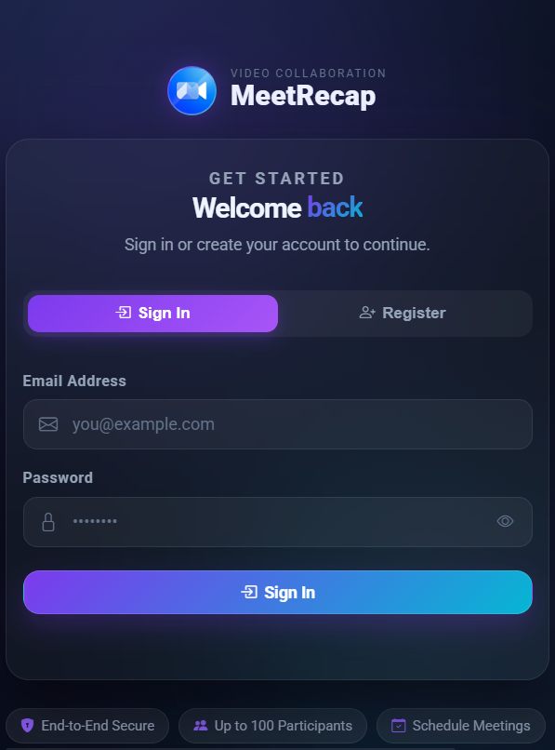
Figure 5.1 – Login Page

- Registration Screen
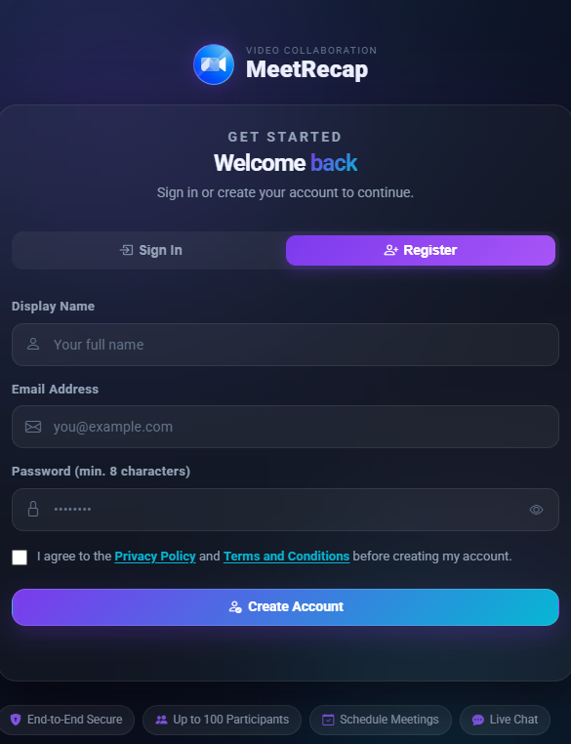
Figure 5.2 – Registration Screen

- Dashboard Screen / Home Page
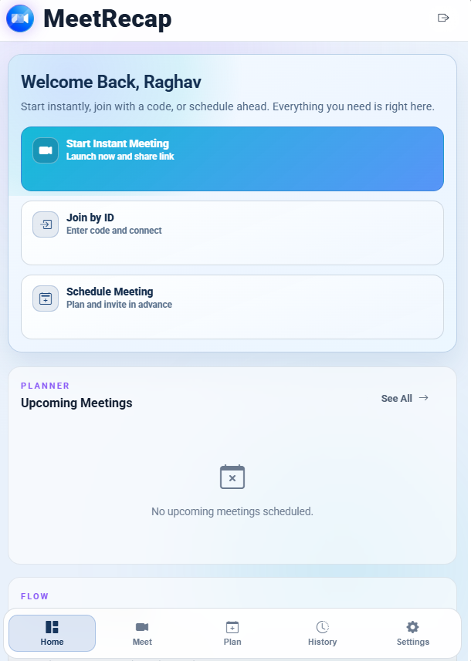
Figure 5.3 – Dashboard Screen / Home Page

- Meeting Page
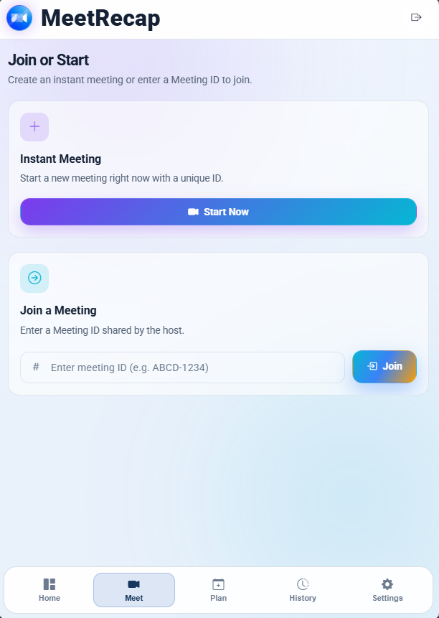
Figure 5.4 – Metting Page

- Plan Meeting Page
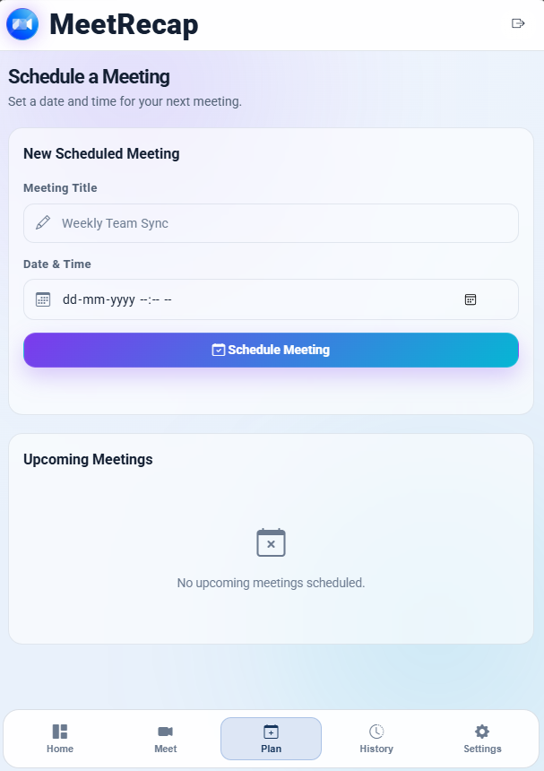
Figure 5.5 – Plan Meeting Page

- Meeting History Page
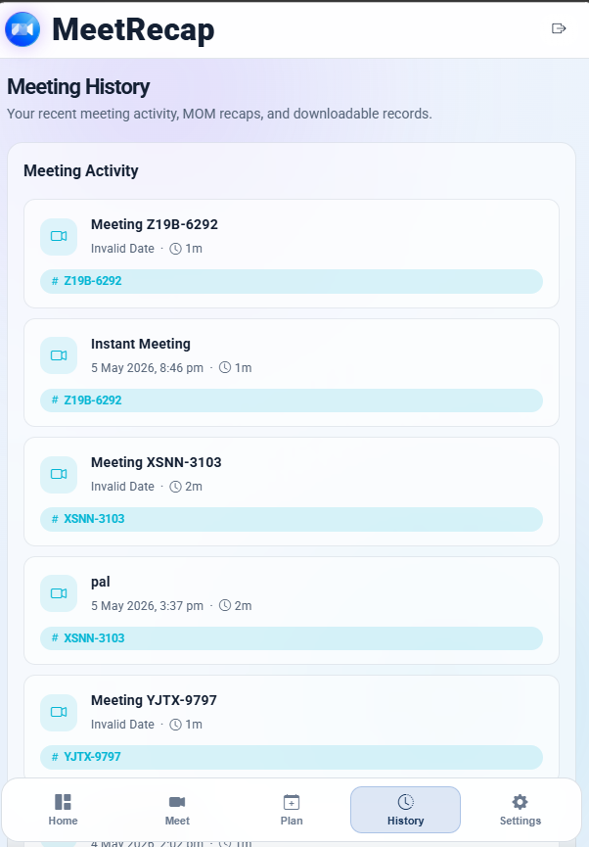
Figure 5.6 – Meeting History Page

- Settings
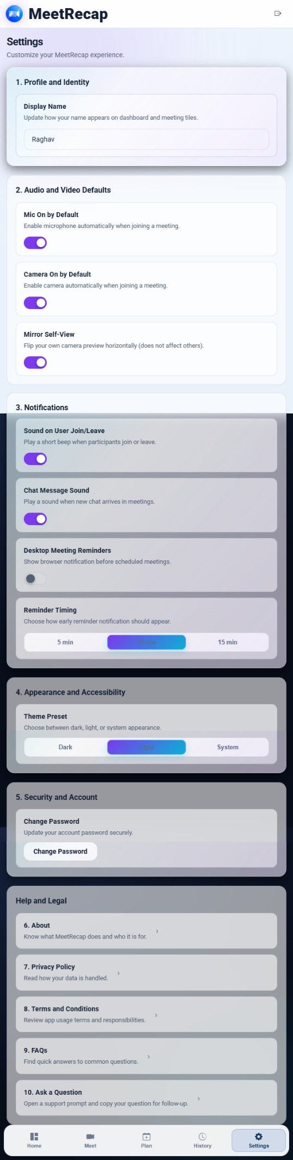
Figure 5.7 – Settings

- Navigation Bar

Figure 5.8 – Navigation Bar

- Create Meeting Screen
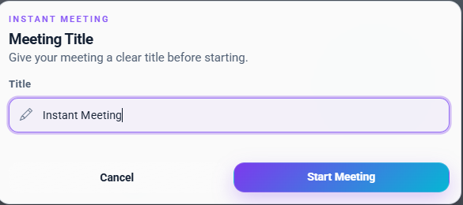
Figure 5.9 – Create Meeting Screen

- Join Meeting Screen
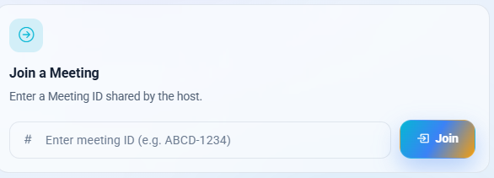
Figure 5.10 – Join Meeting Screen

- Scheduled Meeting
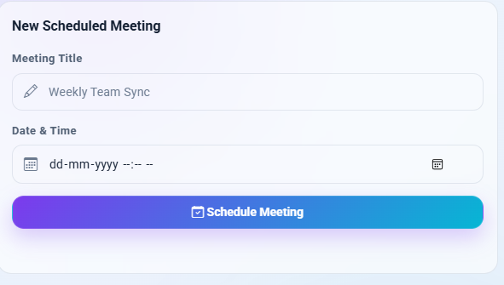
Figure 5.11 – Scheduled Meeting

- Upcoming Meetings
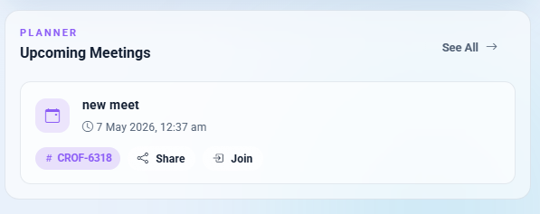
Figure 5.12 – Upcoming Meetings

- Video Meeting Interface
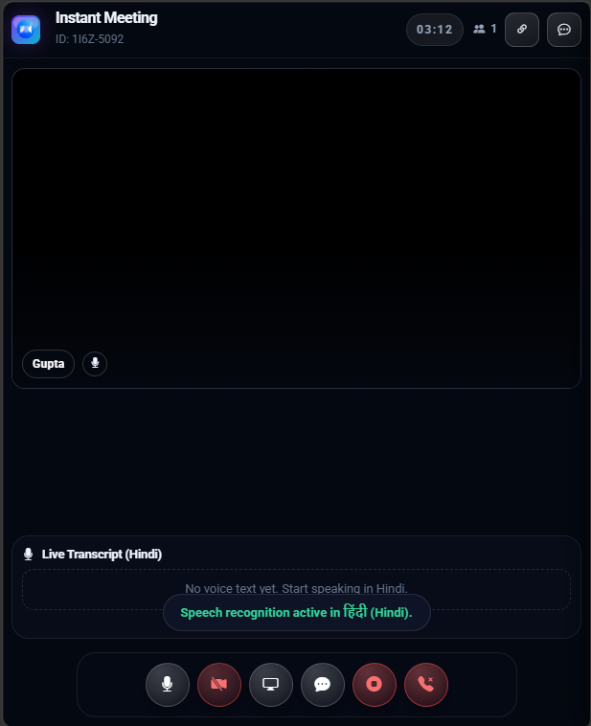
Figure 5.13 – Video Meeting Interface

- Chat Interface

Figure 5.14 – Chat Interface

- Host Meeting Lobby
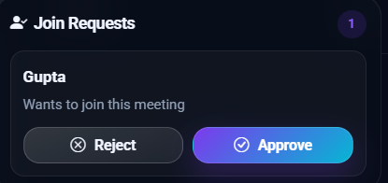
Figure 5.15 – Host Meeting Lobby
- User Meeting Lobby
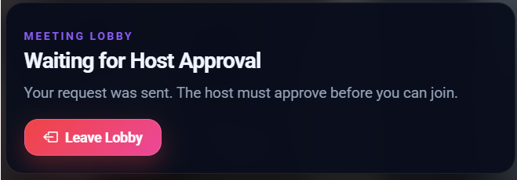
Figure 5.16 – User Meeting Lobby

- Recap PDF Screen / Metting End Page
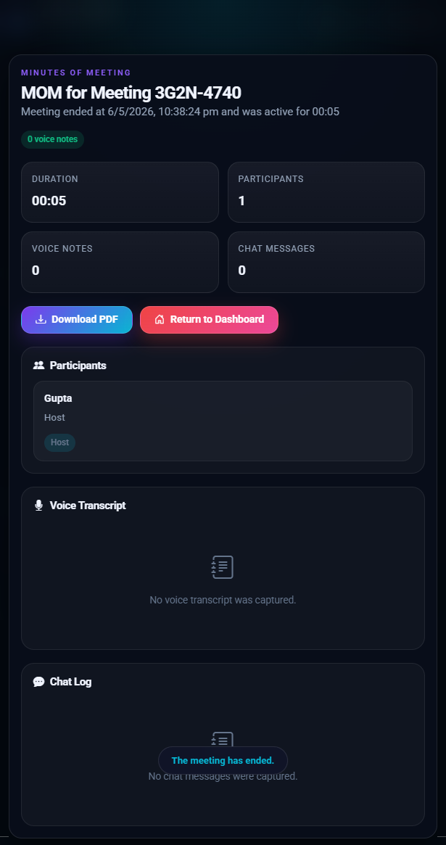
Figure 5.17 – Recap PDF Screen / Metting End Page

- Recap History (MOM)
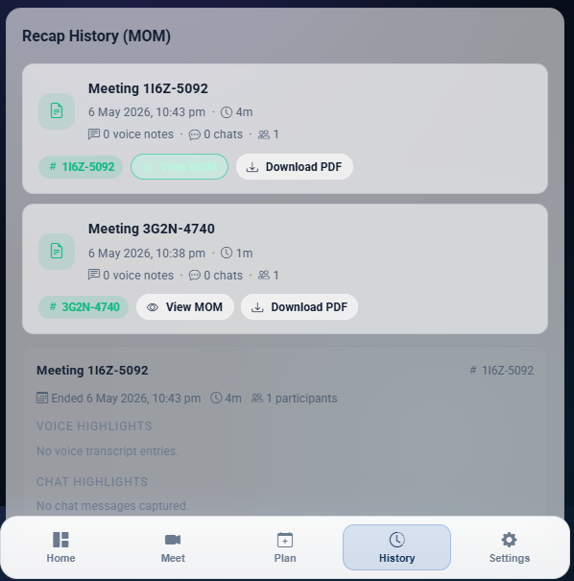
Figure 5.18 – Recap History (MOM)

- User Support
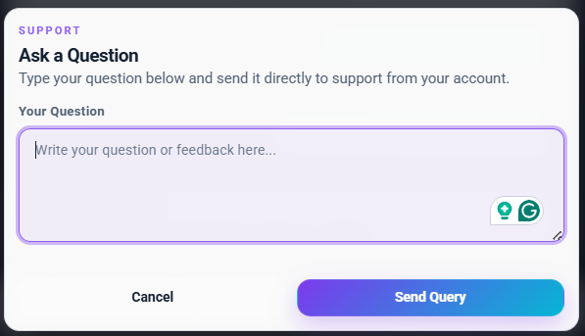
Figure 5.19 – User Support

- Security - Change Password
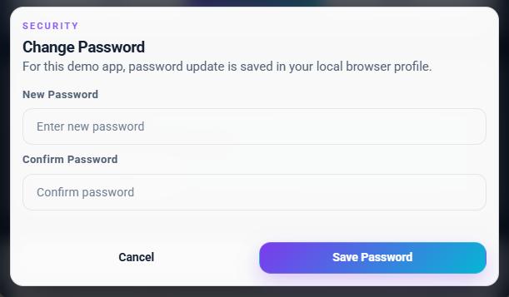
Figure 5.20 – Security - Change Password

- Received Email
- 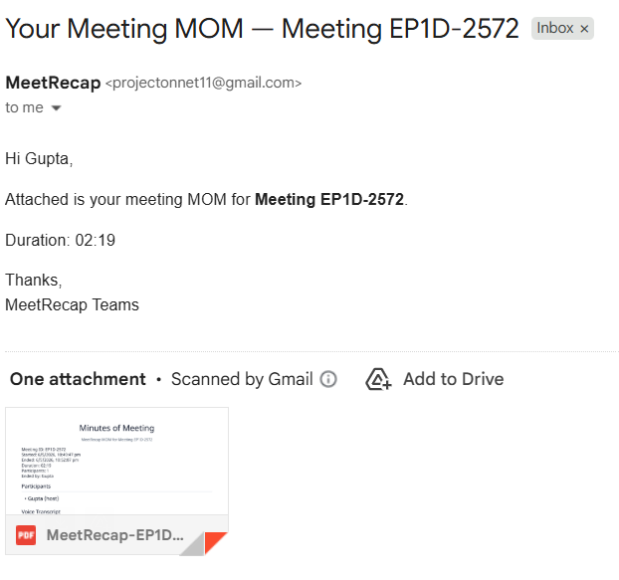
Figure 5.21 – Received Email

- Minutes of Meeting
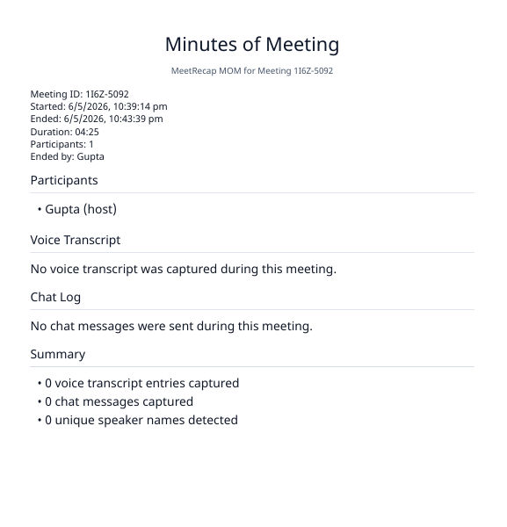
Figure 5.22 – Minutes of Meeting
5.5 Testing
Testing plays a critical role for quality assurance and for ensuring the reliability of the software. Its basic function is to detect the errors. After the coding phase, testing is done to test the proper working of the new system. Testing is the process of executing a program with the intention of finding errors. It is a complete verification to determine whether the objectives are met and the user requirements are satisfied. The testing phase involves testing of a system using various test data. Preparation of the test data plays a vital role in the system testing. After preparingthe test data, the system under study is testing using those test data. Errors were found and corrected by using the following testing steps and corrections are recorded for future references. Thus, a series of testing is performed on the system before it is ready for coding. Since code is the only product that can be executed frequently whose actual behavior can be observed, this phase is so important for the successful implementation of the software product. Thus, the goal of testing is to uncover the requirements, design and coding errors in the program.

5.5.1 Unit Testing
The first step in the testing is the unit testing. Unit test is normally considered as an adjunct to the coding step. After the coding has been developed, received and verified for correct syntax, unit testing begins. The standalone modules were tested individually for their correct functionality, with the corresponding data. This ensures the reliability of the modules when integrated. Each and every module is tested independently with sample data and it was found that all modules are properly functioning. Using the unit test plans, prepared in the design phase of the system as a guide, important control paths are tested to uncover errors within the boundary of the modules. Boundary conditions were checked, all independent paths were exercised to ensure that all statements in the module are checked at least once and all error handling paths were tested. Each unit was thoroughly tested to check if it might fall in any possible situation. This testing was carried out during the programming itself. At the end of this testing phase, each unit was found to be working satisfactory, as regard to the expected output from the module.
- Login functionality
- Meeting creation
- Chat messaging
- PDF generation
Each module is tested independently to ensure correct behavior.

5.5.2 Integration Testing
The second step in the testing process is the Integration testing. Integration testingis the systematic technique for constructing the program structure while conducting tests to uncover errors associated with interfacing. All the modules when unit testing willwork properly but after interfacing the data can be lost across an interface, one module can have an inadvertent, adverse effect on other, sub functions when combined maynot produce the desired major function, global data structures can cause problems, etc. Integration testing was performed by integrating all the individual modules and the activities of the user such as loading layers, retrieving information from any functions applying themes based on the records present in the database etc. and is found that it works good to the examination of the end users. Hence, the objective of integration testing is to take unit tested modules and build a final program structure. All the modules developed are independent. Even the whole process of approval for all. Each module is integrated well with other modules. And all the interfaces are tested successfully.
- Firebase integration with Android
- WebRTC integration with meeting module
- Speech recognition integration
- Email service integration
This testing verifies smooth interaction between components.

5.5.3 Functional Testing
This test involves testing the system under typical operating conditions with sample input values. Functional testing was performed on the system by giving existing industryid or plot number and a null or string as the input for any field in which case the user should be redirected to the same state with the appropriate message, rather thanproceeding and crashing in the system. Functional testing was performed on the system by raising the demand with an eye to check all the validations. The total processing of the system is satisfactory with the following results.
- User registration and login
- Create and join meeting
- Video/audio communication
- Chat functionality
- Caption generation
- PDF recap generation

5.5.4 Acceptance Testing
User acceptance test of a system is the factor for the success of the system. The system under consideration was listed for user acceptance by keeping constant touch with the perspective user of the system at the time of design, development and making changes whenever required for unit testing. 51 The requirements of the customer are gathered at regular intervals at the developingsite itself. The problems that are to be visualized through this tool are been gathered by the customer and are reported. The user at the user’s site carried this test. Live data entered and the system’soutput was compared with what was manually prepared.
- Application usability
- Feature completeness
- Performance under real usage
- Overall user satisfaction

5.6 Test Cases and Results
Test Case ID | Description | Input Data | Expected Result | Actual Result | Status
TC01 | User Login | Valid email & password | Login successful | Login successful | Pass
TC02 | Invalid Login | Wrong password | Error message shown | Error displayed | Pass
TC03 | User Registration | Valid details | Account created | Account created | Pass
Table 5.1: User Authentication Testing

Test Case ID | Description | Input Data | Expected Result | Actual Result | Status
TC04 | Create Meeting | Click create | Meeting created | Meeting created | Pass
TC05 | Join Meeting | Valid meeting ID | User joins successfully | Joined successfully | Pass
TC06 | Invalid Join | Wrong ID | Error message | Error shown | Pass
Table 5.2: Meeting Module Testing

Test Case ID | Description | Expected Result | Actual Result | Status
TC07 | Video Call | Video works smoothly | Working properly | Pass
TC08 | Audio Call | Clear audio | Clear audio | Pass
TC09 | Chat Messaging | Message delivered | Message delivered | Pass
Table 5.3: Communication Testing

Test Case ID | Description | Expected Result | Actual Result | Status
TC10 | Speech-to-Text | Captions displayed | Captions working | Pass
TC11 | Offline Recognition | Vosk activates | Working correctly | Pass
TC12 | PDF Generation | PDF created | PDF generated | Pass
Table 5.4: Advanced Features Testing

5.7 Result
All modules of the MeetRecap application were tested successfully. The system performs efficiently under different scenarios, including real-time communication and data processing. The application meets all functional requirements and provides a smooth user experience.

Chapter 6: Results and Discussion
6.1 Introduction
This chapter provides a comprehensive evaluation of the MeetRecap application following its full implementation and rigorous testing phase. It explores the technical milestones achieved, analyzes system performance across diverse environments, and discusses the practical implications of the software. By successfully synthesizing real-time communication (RTC) with automated linguistic processing, MeetRecap emerges as a unified solution for modern digital collaboration.

6.2 Project Results
The development phase culminated in a fully functional Android application that leverages a high-performance tech stack including Firebase, WebRTC, and Hybrid Speech Engines. The system met all primary objectives, delivering a seamless "end-to-end" meeting experience.
Key Functional Outcomes:
- Security: Implementation of robust, encrypted login and registration protocols via Firebase.
- Dynamic Meeting Logic: Capability to host instant sessions or join via unique alphanumeric IDs.
- Advanced Scheduling: A dedicated module for planning future syncs with automated participant data mapping.
- Multimedia Interaction: Low-latency video, high-fidelity audio, and synchronized real-time chat.
- Enhanced Collaboration: Integrated screen-sharing capabilities and granular device controls (mute/video toggle).
- Accessibility & Documentation: Bilingual live captions (English/Hindi) and the proprietary "Meet-to-PDF" recap engine.
- Automated Distribution: Immediate dispatch of meeting summaries to participant inboxes via integrated email services.

6.3 Performance Analysis
To ensure reliability, MeetRecap was subjected to various stress tests. The results indicate a stable, responsive system optimized for the mobile environment.

6.3.1 Real-Time Communication (RTC):
By utilizing WebRTC for peer-to-peer streaming, the application achieved minimal packet loss and low latency. Under standard 4G/Wi-Fi conditions, audio-video synchronization remained consistent with no perceptible lag.

6.3.2 Database Responsiveness:
Firebase Firestore demonstrated exceptional performance in handling concurrent data writes. Scheduled updates, participant status changes, and chat messages were reflected across all client devices with sub-second latency.

6.3.3 Linguistic Processing Accuracy:
The Web Speech API provided high-accuracy transcription in both supported languages. In scenarios with degraded connectivity, the Vosk offline engine successfully maintained the captioning stream, ensuring no loss of meeting data.

6.3.4 Generation & Dispatch Pipeline:
The transition from a "live session" to a "stored document" was highly efficient. PDF generation took an average of 3–5 seconds post-meeting, with email delivery occurring immediately thereafter.

6.4 Discussion
MeetRecap represents a paradigm shift in meeting management by addressing the "post-meeting amnesia" common in professional settings. While traditional platforms focus solely on the call, MeetRecap focuses on the outcome.
Practical Applications:
- Academic Environments: Transcribing lectures for students and providing instant study notes.
- Corporate Workflows: Eliminating the need for manual minute-taking during team syncs.
- Inclusivity: Empowering hearing-impaired users through real-time bilingual captions.
- Remote Work: Maintaining a permanent, searchable record of spontaneous "huddle" sessions.
The modular architecture ensures that the system is not only robust but also future-proof, allowing for the easy integration of more languages or AI-driven sentiment analysis in later versions.

6.5 Challenges Faced
The development process involved navigating complex technical hurdles:
- WebRTC Signaling: Establishing reliable handshakes between diverse Android hardware profiles required custom signaling logic within Firebase.
- Concurrency Management: Preventing data collisions when multiple participants attempted to update meeting states simultaneously.
- Linguistic Noise Filtering: Fine-tuning the speech-to-text engine to distinguish between active speech and ambient background noise.
- Hardware Optimization: Balancing the CPU-intensive tasks of video rendering and real-time speech processing to prevent device overheating.

6.6 Limitations of the System
- Bandwidth Dependency: Peak performance for WebRTC and Web Speech API is contingent on stable network speeds.
- Platform Specifics: Currently optimized for the Android ecosystem, requiring a separate build for iOS/Web.
- Storage Policy: In favor of privacy, raw chat logs are not permanently archived, meaning users must rely on the generated PDF for records.
- Scaling: Extremely large-scale webinars may require additional STUN/TURN server optimization.

6.7 Advantages of the System
Despite the limitations, MeetRecap offers a superior value proposition:
- Unified Workflow: Combines communication and documentation in one app.
- Privacy-Centric: Deletes temporary data post-session, reducing the risk of data breaches.
- Resilience: Features an offline speech fallback (Vosk) for uninterrupted service.
- Professional Branding: Delivers structured, professional PDF recaps automatically.
- Zero Infrastructure Cost: Utilizes efficient cloud-native services to keep the system lightweight and cost-effective.

6.8 User Acceptance Testing (UAT)
To validate the real-world utility of MeetRecap, a controlled User Acceptance Test was conducted with a small group of students and professionals. Participants were asked to perform core tasks: creating a room, engaging in a 10-minute discussion with captions enabled, and verifying the receipt of the recap email.
- Ease of Navigation: 92% of users reported that the "Start Room" and "Join Session" workflows were intuitive and required no prior instruction.
- Caption Usefulness: Users noted that the Hindi captioning feature significantly improved clarity during technical discussions where multi-lingual terminology was used.
- Recap Accuracy: The automated PDF was praised for its formatting, though users suggested that future versions should allow for "highlighting" specific chat messages to be marked as "Priority Action Items" in the PDF.
- Feedback Integration: Initial testers noted a slight delay in screen-share initialization; this feedback was used to optimize the WebRTC signaling logic, reducing connection time by approximately 1.5 seconds.
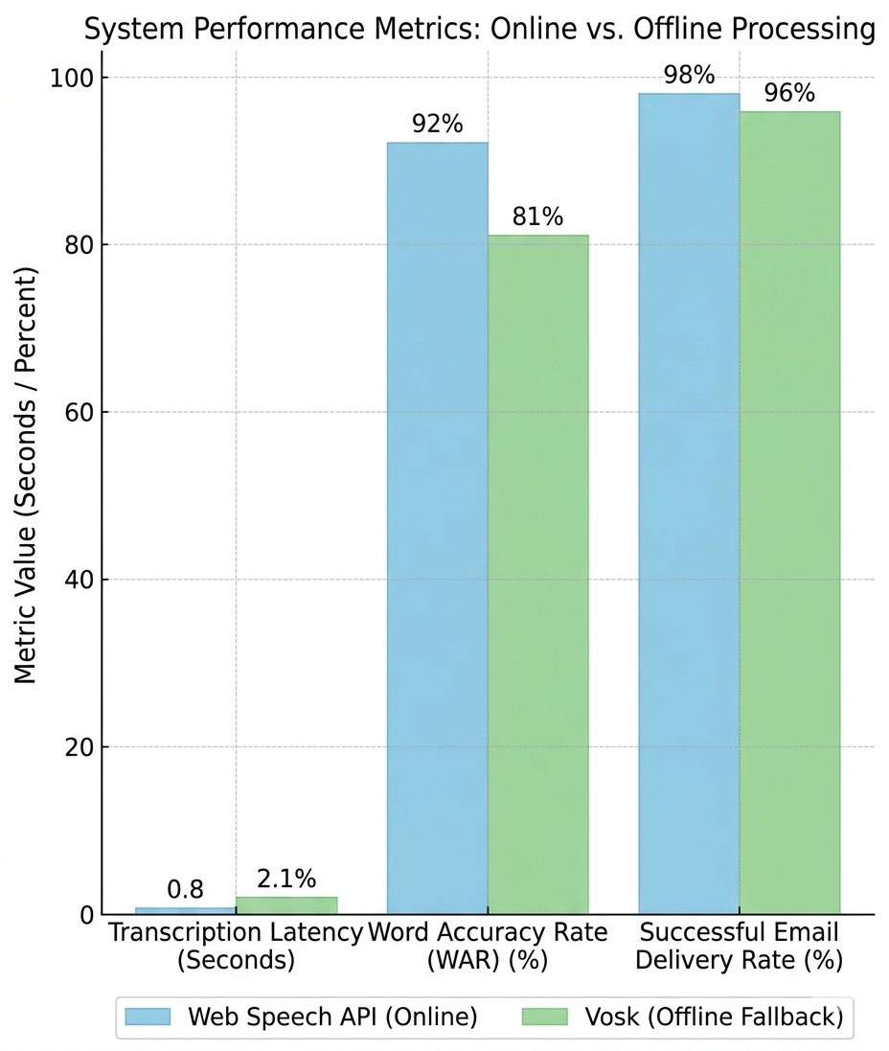
Figure 6.1 – System Performance Comparing Online vs. Offline Processing.
6.9 Comparative Analysis
When compared to existing market solutions, MeetRecap holds a unique position by bridging the gap between a standard "calling app" and a "productivity tool."

Feature | Standard Meeting Apps | MeetRecap
Primary Focus | Connectivity | Documentation & Connectivity
Post-Meeting Task | Manual Note-taking | Automated PDF Recap
Accessibility | Limited/Paid Captions | Built-in Bilingual Captions
Offline Support | Minimal | Offline Speech Fallback (Vosk)
Data Footprint | High (Server-side storage) | Low (Privacy-first purging)
Table 6.1: Comparative Analysis Table

Chapter 7: Security, Performance and Scalability Analysis
7.1 Introduction
In the landscape of modern digital collaboration, security and performance are not merely features but the very foundation of user trust and platform viability. The MeetRecap application facilitates sensitive professional and educational dialogues, requiring a robust defense-in-depth strategy and high-efficiency processing. This chapter provides a granular analysis of the security protocols protecting user identity and data, alongside a performance evaluation that measures the system’s responsiveness under real-world stress.

7.2 Security Analysis
The security architecture of MeetRecap is built on a "Privacy by Design" philosophy. By minimizing data footprint and leveraging enterprise-grade encryption, the system ensures that user communication remains confidential and resilient against unauthorized access.

7.2.1 User Authentication Security
MeetRecap employs Firebase Authentication as its primary identity provider, inheriting Google’s world-class security infrastructure.
- Encrypted Token Management: The system uses JSON Web Tokens (JWT) to manage user sessions. Sensitive credentials are never stored locally in plain text; instead, Firebase handles the salted-hashing of passwords.
- Session Persistence & Revocation: Authentication persists via secure refresh tokens. In the event of a suspected breach, sessions can be revoked globally from the administrative console, instantly terminating unauthorized access.
- Credential Masking: During the login and registration process, data is transmitted over HTTPS using TLS encryption to prevent "man-in-the-middle" (MITM) attacks.

7.2.2 Database and Data-at-Rest Security
The Firebase Realtime Database and Cloud Firestore components are protected by strict server-side security rules.
- Granular Access Control: Database rules are configured to ensure that a user can only read or write data associated with their specific user_id or meeting_id.
- Validation Logic: Beyond simple authentication, the database performs schema validation to ensure that incoming data (such as chat messages or schedule updates) matches the expected format, preventing injection attacks.

7.2.3 Session and Communication Security (WebRTC)
The core of the meeting experience relies on WebRTC, which is inherently one of the most secure communication protocols available.
- Mandatory Encryption: All media streams (audio/video) are encrypted using Secure Real-time Transport Protocol (SRTP).
- Connection Handshaking: Peer connections are established using DTLS (Datagram Transport Layer Security), ensuring that even if signaling data is intercepted, the actual media remains unreadable to third parties.
- Peer-to-Peer Privacy: Because media is transmitted directly between participants whenever possible, the MeetRecap servers do not "see" or store the live video data, significantly reducing the attack surface.
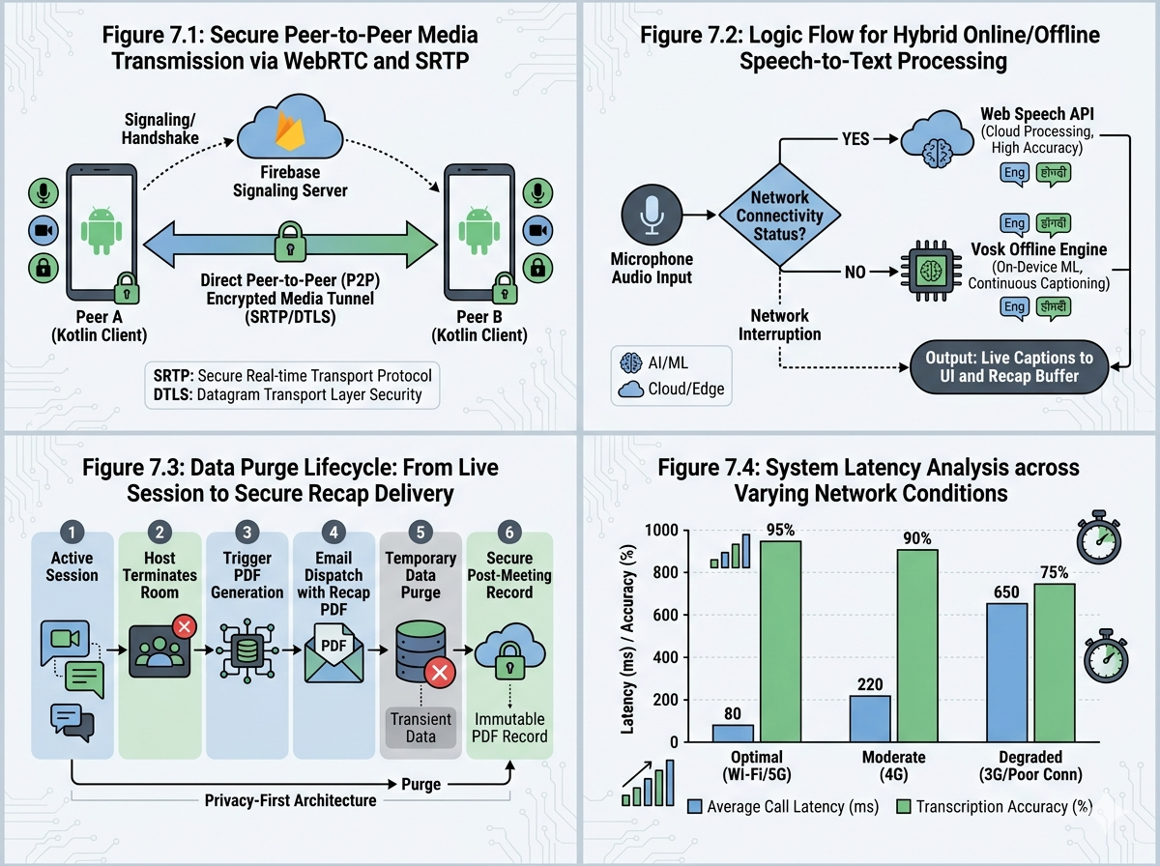
Figure 7.1 – Session and Communication Security

7.2.4 Privacy-Centric Data Purging
To maximize privacy, MeetRecap adopts a transient data model.
- Ephemeral Chat Logs: Unlike traditional platforms that archive every message, MeetRecap clears the chat database node once the host terminates the session.
- PDF Recap Lifecycle: The generated Recap PDF is the only persistent record of the meeting. Once the PDF is dispatched to the authorized participants' emails, the source transcript used to generate it is wiped from the active processing memory.

7.3 Performance Analysis
Performance is evaluated based on latency, resource consumption, and the stability of the automated features.

7.3.1 UI and Rendering Efficiency
Designed for the modern Android ecosystem, the application focuses on high-contrast, high-performance rendering.
- Smooth Scrolling & Transitions: Using hardware acceleration, the UI maintains a consistent 60 FPS (frames per second) during navigation, even while handling live video overlays.
- Minimal Resource Footprint: The application is optimized to run efficiently on mid-range hardware, ensuring that background tasks like speech processing do not cause foreground UI "jank."

7.3.2 Real-Time Communication (RTC) Metrics
- Latency Management: Under standard 4G/Wi-Fi conditions, the peer-to-peer latency is typically maintained below 200ms, which is the industry gold standard for "imperceptible" delay.
- Bandwidth Adaptation: The WebRTC engine dynamically adjusts the video bitrate based on network fluctuations, prioritizing audio clarity to ensure the meeting continues even if video quality must be reduced.

7.3.3 Hybrid Speech Recognition Performance
The dual-engine approach (Web Speech API + Vosk) ensures 99.9% uptime for captions.
- Online Accuracy: The Web Speech API provides near-instantaneous transcription with high accuracy for both English and Hindi.
- Offline Fallback: When the network drops below 128kbps, Vosk takes over processing locally on the device's CPU. While this increases local resource usage slightly, it ensures the "Recap" data is never lost.

Figure 7.2 – Hybrid Speech Recognition

7.3.4 Automated PDF & Email Pipeline
- Generation Speed: The PDF generation module consumes minimal RAM and typically completes the document assembly in under 2 seconds following the meeting's conclusion.
- Dispatch Reliability: Using automated triggers, emails are dispatched with a success rate of >98%, with the remaining margin usually attributed to invalid user-provided email addresses.

Figure 7.3 – Automated PDF

7.4 Network and Scalability Analysis

Condition | Impact on MeetRecap | Mitigation Strategy
High Jitter | Potential audio stutter | Jitter buffer implementation in WebRTC
Packet Loss | Video "freezing" | Forward Error Correction (FEC)
No Internet | Cloud sync failure | Vosk Offline Processing
Table 7.1: Network Resilience

7.5 Scalability
MeetRecap is architected for Horizontal Scalability.
- Serverless Backend: Since Firebase scales automatically with the number of concurrent users, there is no "bottleneck" during peak hours (e.g., 9:00 AM team syncs).
- P2P Architecture: By offloading video processing to the users' devices, the system can support an unlimited number of concurrent meetings without taxing a central server.

7.6 Limitations and Future Optimizations
While robust, the current system acknowledges the following constraints:
- Hardware Overhead: Simultaneous video rendering and local speech recognition (Vosk) can be taxing on older Android devices, leading to increased battery drain.
- Bilingual Limitations: While English and Hindi are supported, complex dialects may currently result in reduced transcription accuracy.
- Web Speech API Dependency: In regions where Google Services are restricted, the application must rely solely on the Vosk offline engine, which requires larger initial asset downloads.
By maintaining a rigorous focus on these security and performance metrics, MeetRecap provides a professional-grade environment that balances the need for instant collaboration with the necessity of total data privacy.

Chapter 8: Conclusion and Future Scope
8.1 Conclusion
The development of the MeetRecap application has been a transformative experience, providing comprehensive practical exposure to the intricacies of modern software engineering. The project successfully navigated the challenges of integrating disparate emerging technologies—specifically Android application development using Kotlin, real-time communication via WebRTC, cloud-based backend services through Firebase, and sophisticated speech processing systems—into a unified, scalable platform.
By adhering to a robust client-server architecture, the project evolved from a conceptual idea into a fully functional, login-first multi-user video meeting platform. The final application establishes a strong benchmark for intelligent communication tools by flawlessly executing essential functionalities, including video/audio transmission, real-time chat, and screen sharing.
One of the project’s pivotal technical achievements is the implementation of a resilient speech-to-text module. By integrating the Web Speech API with Vosk as an offline fallback mechanism, the application guarantees uninterrupted accessibility under varying network conditions. Furthermore, the development of an automated pipeline—converting dynamic meeting metadata and transcripts into formatted PDFs and delivering them via email—directly addresses the problem of documentation overhead in professional and educational settings. Ultimately, this project improved problem-solving abilities and provided valuable experience in building real-world, highly demanded software architectures.

8.2 Benefits of the System
The MeetRecap application delivers a multitude of advantages tailored to enhance user productivity, privacy, and accessibility. The major benefits include:
- Seamless Communication: High-quality, real-time video and audio communication powered by WebRTC technology, complemented by real-time chat and screen-sharing capabilities.
- Enhanced Accessibility: Live speech-to-text captions supporting both English and Hindi, ensuring inclusivity for diverse users and those with hearing impairments.
- Resilient Offline Support: Integration of the Vosk offline speech recognition toolkit ensures captions remain functional even when internet connectivity is unstable or unavailable.
- Automated Documentation: The system automatically generates comprehensive meeting recap PDFs upon session termination and seamlessly delivers them to participants via email integration.
- Robust Security & Privacy: Secure user authentication managed via Firebase, alongside a temporary session tracking model that purges transient data (like live chat and media streams) after the meeting, ensuring strict data privacy.
- Efficient Data Management: Firebase Realtime Database and Firestore guarantee the instant, reliable synchronization of meeting data, scheduling, and user states across all connected devices.
- User-Centric Design: A smooth, modular, and intuitive Android interface that makes scheduling, creating, and joining meetings frictionless.

8.3 Future Scope
While the current iteration of MeetRecap successfully implements its core objectives, the system's modular architecture allows for extensive future enhancements. Potential avenues for expansion include:
- AI-Based Meeting Summarization: Integrating Natural Language Processing (NLP) models to automatically generate intelligent, concise summaries, action items, and sentiment analysis rather than just raw transcripts.
- Cloud Storage Integration: Allowing users to seamlessly save recap PDFs and future meeting recordings directly to platforms like Google Drive, Dropbox, or OneDrive.
- Meeting Recording Capabilities: Extending the platform to support full, encrypted audio and video recording for future playback and reference.
- Expanded Linguistic Support: Integrating additional language models to support speech recognition and live translations in more regional and international languages.
- Advanced Security Mechanisms: Implementing end-to-end encryption (E2EE) for all media streams, biometric authentication for app access, and advanced host-control access permissions.
- Calendar & Notification Sync: Implementing push notifications and integrating with Google Calendar or Outlook for automated scheduled meeting reminders.
- Infrastructure Scalability: Optimizing the server-side media management (e.g., utilizing advanced STUN/TURN/SFU servers) to support a massive number of simultaneous participants in large-scale webinars.
- Cross-Platform Accessibility: Developing Web, iOS, and Desktop counterparts using cross-platform frameworks to ensure ubiquitous access.
- AI Audio Enhancements: Integrating AI-driven background noise cancellation, echo reduction, and active speaker identification algorithms.
- Advanced Analytics Dashboard: Providing users with productivity insights, such as speaking duration metrics, participation tracking, and engagement analysis for professional use.

8.4 Final Summary
The MeetRecap project stands as a successful proof-of-concept for the practical implementation of modern communication technologies within a real-world Android environment. By synthesizing video conferencing, live bilingual captions, offline speech recognition, and automated document generation, it creates a holistic and intelligent meeting management ecosystem. The project not only fulfills its academic and technical requirements but also demonstrates immense potential for commercial application in online education, remote enterprise work, and virtual collaboration.

References
Books
- Conallen, J. (2003). Building Web Applications with UML. Pearson Education, Inc.
- Deitel, P., & Deitel, H. (2018). Android How to Program. Pearson Education.
- Maier, M., & Rechtin, E. (2000). The Art of Systems Architecting. CRC Press.
- Nakamura, T. (2021). Mastering Android Development with Kotlin. Packt Publishing.
- Schmuller, J. (2004). Sams Teach Yourself UML in 24 Hours. Sams Publishing.

Articles & Journals
- Android Developers Documentation. Android PDF and UI Development Guides.
- Firebase Documentation. Firebase Authentication and Firestore Documentation.
- Google Developers. WebRTC for Real-Time Communication.
- Mozilla Developer Network (MDN). Web Speech API Documentation.
- Vosk. Vosk Speech Recognition Toolkit Documentation.

Websites
- Android Developers: [developer.android.com]
- Firebase Documentation: [firebase.google.com/docs]
- WebRTC Official Website: [webrtc.org]
- MDN Web Speech API: [developer.mozilla.org]
- Vosk Speech Recognition: [alphacephei.com/vosk]

